HANOI UNIVERSITY OF SCIENCE AND TECHNOLOGY

School of Information and communications technology

Software Design Document

Version 1.3

AIMS: An Internet Media Store

IT4549E ITSS Software Development

Group 3

|  |  |
| --- | --- |
| Trần Thị Lan Anh | 20215180 |
| Ngô Xuân Bách (Leader) | 20215181 |
| Trần Thủy Châu | 20215182 |
| Đào Minh Chí | 20200082 |
| Bùi Hữu Thành Công | 20205176 |

*Hanoi,* *June 17, 2024*

*<All notations inside the angle bracket are not part of this document, for its purpose is for extra instruction. When using this document, please erase all these notations and/or replace them with corresponding content as instructed>*

*<This document, written by Prof. NGUYEN Thi Thu Trang, is used as a case study for student with related courses. Any modifications and/or utilization without the consent of the author is strictly forbidden>*

Table of Contents

Table of Contents 1

1 Introduction 5

1.1 Objective 5

1.2 Scope 5

1.3 Glossary 5

1.4 References 5

2 Overall Description 7

2.1 General Overview 7

2.2 Assumptions/Constraints/Risks 7

2.2.1 Assumptions 7

2.2.2 Constraints 7

2.2.3 Risks 8

3 System Architecture and Architecture Design 9

3.1 Architectural Patterns 9

3.2 Interaction Diagrams 9

3.3 Analysis Class Diagrams 9

3.4 Unified Analysis Class Diagram 9

3.5 Security Software Architecture 9

4 Detailed Design 10

4.1 User Interface Design 10

4.1.1 Screen Configuration Standardization 10

4.1.2 Screen Transition Diagrams 10

4.1.3 Screen Specifications 10

4.2 Data Modeling 10

4.2.1 Conceptual Data Modeling 10

4.2.2 Database Design 10

4.3 Non-Database Management System Files 11

4.4 Class Design 11

4.4.1 General Class Diagram 11

4.4.2 Class Diagrams 11

4.4.3 Class Design 11

5 Design Considerations 13

5.1 Goals and Guidelines 13

5.2 Architectural Strategies 13

5.3 Coupling and Cohesion 14

5.4 Design Principles 14

5.5 Design Patterns 14

# Introduction

## Objective

This document provides a design and detailed description of the whole system, user management, user groups, and the functions each user role can use at runtime. It also outlines the objectives and features of the system, the interface, and the system's constraints regarding external impacts.

This document is intended for stakeholders and software developers.

## Scope

The AIMS Project is a desktop e-commerce software designed to facilitate the buying and selling of media products such as books, CDs, LP records, and DVDs.

This software will enable users to browse, search for, and purchase various media items seamlessly. It also includes functionalities for administrators to manage users and for store managers to manage and make changes to products, ensuring efficient management of the product inventory. However, the focus within the scope of this project will not cover extensive account authentication or user management functionalities.

The primary objective of the AIMS Project is to provide a robust and user-friendly platform for media transactions, benefiting both consumers and creators by making media products more accessible and supporting the financial sustainability of artists and intellectuals. This description aligns with higher-level specifications if they exist, ensuring consistency in the project's goals and objectives.

## Glossary

|  |  |  |  |  |
| --- | --- | --- | --- | --- |
| *No* | *Term* | *Explanation* | *Example* | *Note* |
|  | Administrator | Users with privileges manage other users | In AIMS, administrator can create new users, view, update, or delete user information, reset passwords, and set or change user roles. |  |
|  | Cart | A temporary container where customers can add products for purchase. | In AIMS, it displays product information, quantities, prices, and notifies customers of insufficient inventory. |  |
|  | CRUD operations | CRUD is an acronym that stands for Create, Read, Update, and Delete. |  |  |
|  | Customer | User role accessing e-commerce software to browse, search, and purchase products |  |  |
|  | Downtime | It refers to the period during which a system, service, or application is unavailable or not operational |  |  |
|  | Inflation | Inflation refers to the general increase in prices of goods and services within an economy over time. |  |  |
|  | Order | A request by a customer to purchase products | Within the AIMS software, it includes product details, delivery information, and payment method. |  |
|  | Pending Processing | The status of an order awaiting review or approval |  |  |
|  | Product Manager | A user role responsible for managing products within an e-commerce platform | In AIMS, product managers can add or edit one product at a time, delete up to 10 products simultaneously, and cannot delete or update more than 30 products for security reasons. They can add an unlimited number of products per day. |  |
|  | Response time | Response time is the duration it takes for a system or application to respond to a user's request or input |  |  |
|  | Rush Order Delivery | A delivery option that prioritizes faster delivery times for additional fee | The service offered within the AIMS software, allowing customers to receive items within a prearranged timeframe of 2 hours. Available only for addresses within specific districts of Hanoi. |  |
|  | Scalability | Scalability refers to the ability of a system, such as software or hardware infrastructure, to handle an increasing amount of workload or users while maintaining performance and efficiency |  |  |
|  | Transaction ID | A unique identifier assigned to each payment transaction |  |  |
|  | Uptime | Uptime is a measure of the time duration during which a system, service, or application is operational and available for use |  |  |
|  | Value-added Tax (VAT) | A 10% tax added to the value and price of media products at the point of sale |  | It will be caluculated in the final price of the inventory |
|  | VNPay | A secure online service that authorizes payments between customers and businesses | VNPay is integrated with the AIMS software, allowing customers to complete transactions using credit cards. |  |

## References

|  |  |
| --- | --- |
| [1] | Centers for Medicare & Medicaid Services, "System Design Document Template," [Online]. Available: https://www.cms.gov/Research-Statistics-Data-and-Systems/CMS-Information-Technology/XLC/Downloads/SystemDesignDocument.docx. |

# Overall Description

## General Overview

The AIMS Project is a desktop e-commerce software designed to facilitate the buying and selling of media products such as books, CDs, LP records, and DVDs. The basic design approach focuses on user-friendly navigation, efficient product management, and robust transaction processing. The system architecture supports up to 1,000 simultaneous users and can operate continuously for 300 hours without failure. The design goals emphasize performance, reliability, and ease of use.

High-level context diagrams, such as general use case diagrams and activity diagrams, illustrate the interaction between customers, product managers, and administrators. Any updates to these diagrams are based on new insights to ensure accuracy and clarity.

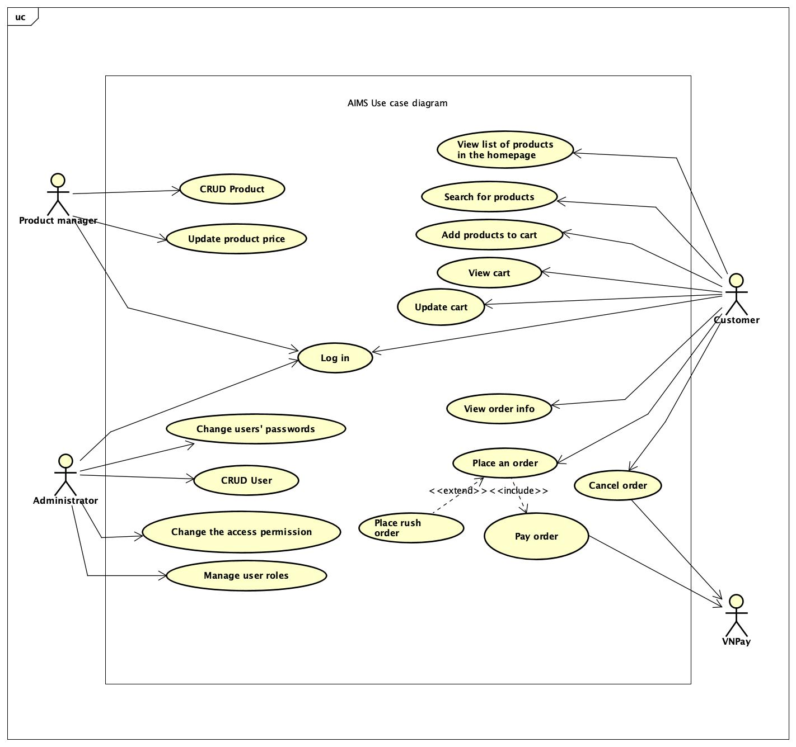

Figure 1. General Use case Diagram

## Assumptions/Constraints/Risks

### Assumptions

* The software, which is a Java-based application, will run on standard desktop operating systems, including Windows and macOS.
* Users will have a basic understanding of e-commerce platforms and digital transactions.
* The system will rely on VNPay for payment processing, assuming VNPay's API remains stable and well-documented.

### Constraints

* Hardware/Software Environment: The system is constrained by the performance capabilities of users' desktop hardware and the compatibility with Windows and macOS operating systems.
* End-User Environment: Assumes access to a stable internet connection for real-time transactions.
* Resource Availability: Relies on the availability of VNPay for payment processing and email services for notifications.
* Standards Compliance: Must comply with local regulations regarding e-commerce and digital transactions, including tax laws.
* Security Requirements: Implements measures to protect user data and transaction information, following industry standards for encryption and secure communications.
* Performance Requirements: The system is designed to maintain a response time of 2 seconds under normal conditions and 5 seconds during peak hours.
* Network Communications: Requires a reliable network infrastructure to handle multiple concurrent transactions.
* Verification and Validation Requirements: Thorough testing to ensure all functionalities work as intended, including edge cases related to inventory and payment processing.

### Risks

* System Performance: Risk of degraded performance if user load exceeds 1,000 simultaneous users. Mitigation involves load testing and potential scaling solutions.
* Payment Processing: Dependence on VNPay poses a risk if their service is interrupted. Mitigation includes implementing contingency plans for payment delays or failures.
* Data Security: Risk of data breaches could compromise user information. Mitigation involves robust encryption methods, regular security audits, and compliance with data protection regulations.

# System Architecture and Architecture Design

## Architectural Patterns

The AIMS Project employs a 3-tier architecture, which is a well-established architectural pattern that separates the application into three distinct layers: the presentation layer, the business logic layer, and the data layer.

The Presentation Layer is responsible for interacting with the user. It includes the user interface components and handles user input and output. The Business Logic Layer contains the core functionality and business rules of the application. It processes user inputs, makes logical decisions, and performs computations. The Data Layer is responsible for data storage, retrieval, and manipulation. It interacts with the database and other data sources.

Reasons for choosing the 3-tier architecture:

* Faster development: Because each tier can be developed simultaneously by different teams, an organization can bring the application to market faster. And programmers can use the latest and best languages and tools for each tier.
* Improved scalability: Any tier can be scaled independently of the others as needed.
* Improved reliability: An outage in one tier is less likely to impact the availability or performance of the other tiers.
* Improved security: Because the presentation tier and data tier can't communicate directly, a well-designed application tier can function as an internal firewall, preventing SQL injections and other malicious exploits.

## Interaction Diagrams

1. Add products to cart

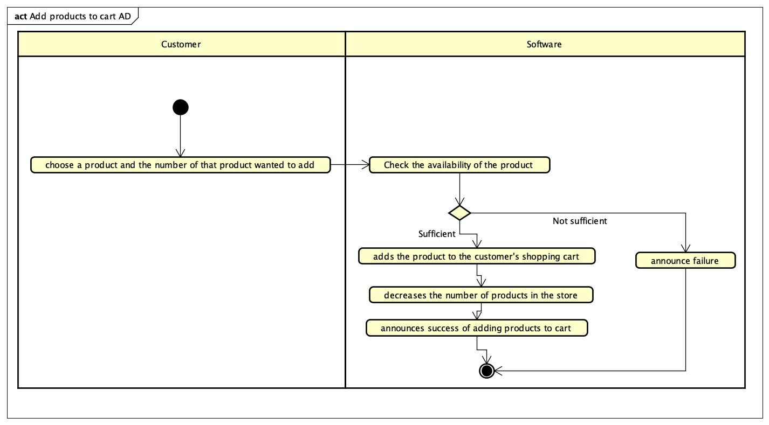

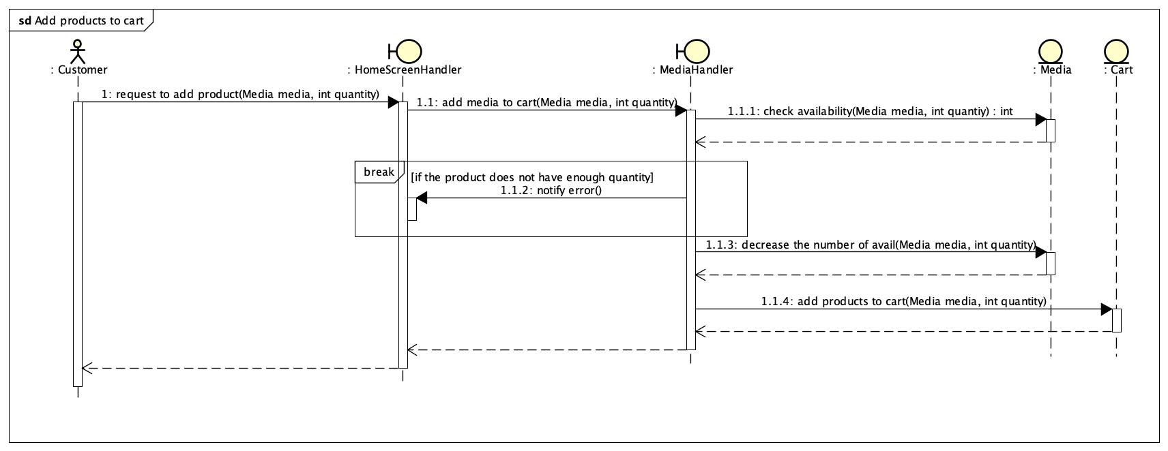

1. Search for products

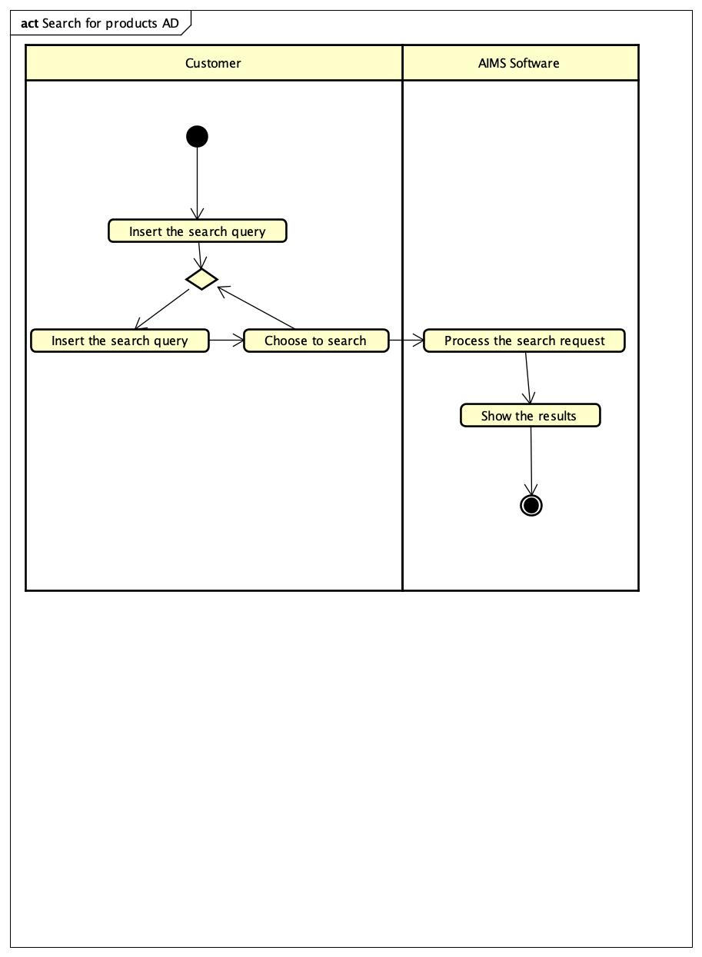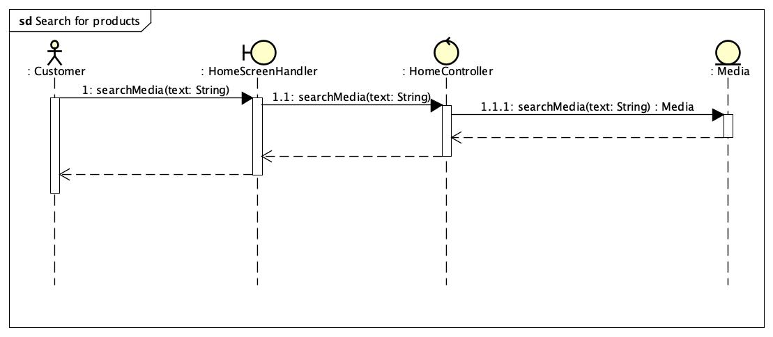

1. Update cart

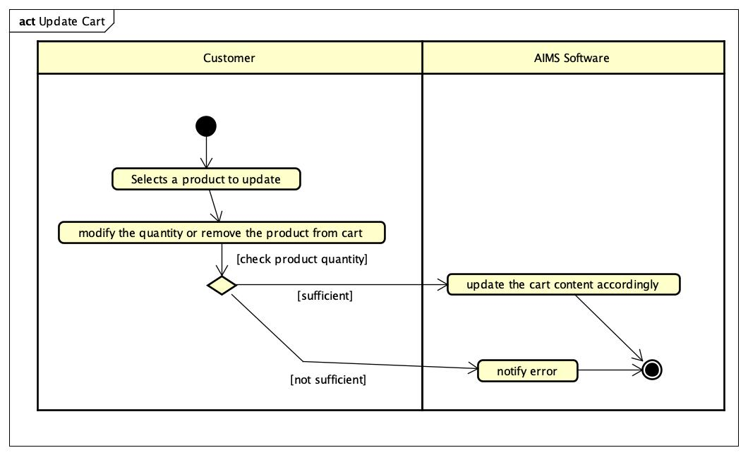

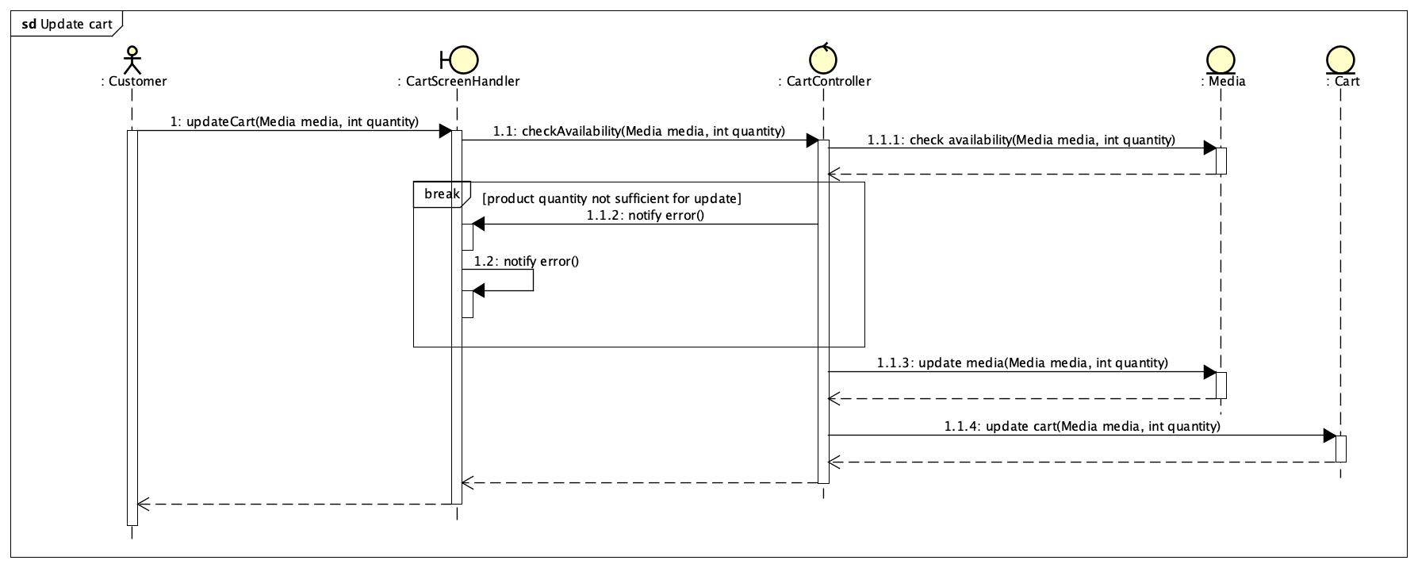

1. View cart

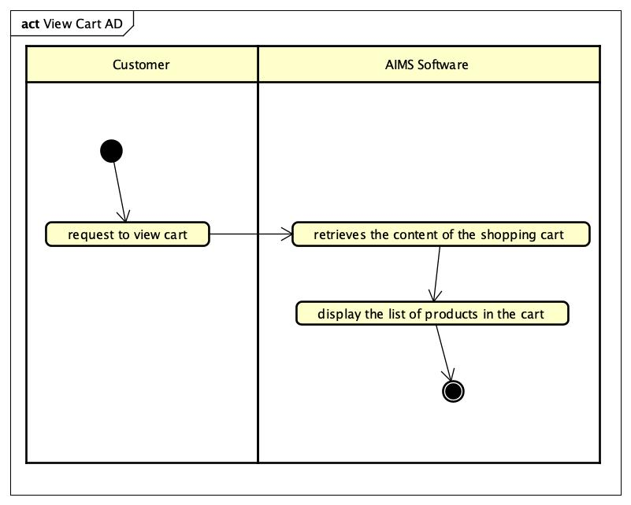

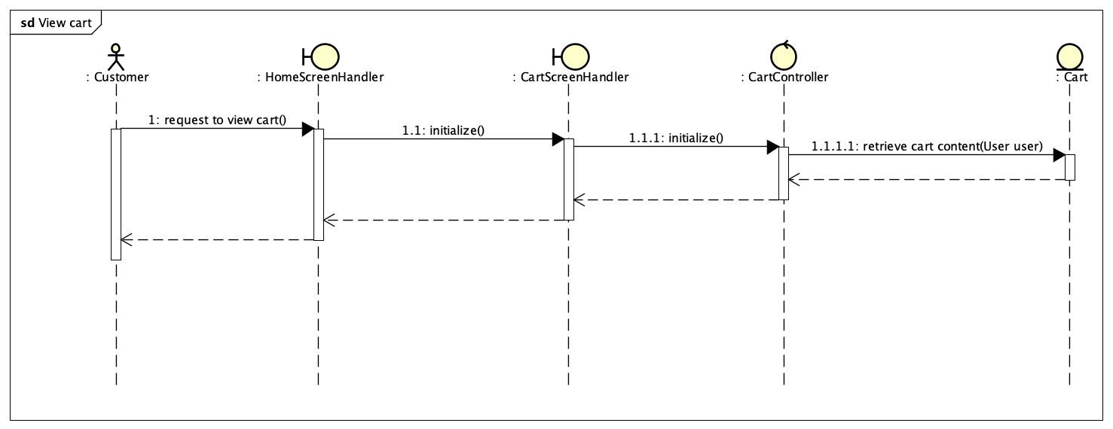

1. View list of products in homepage

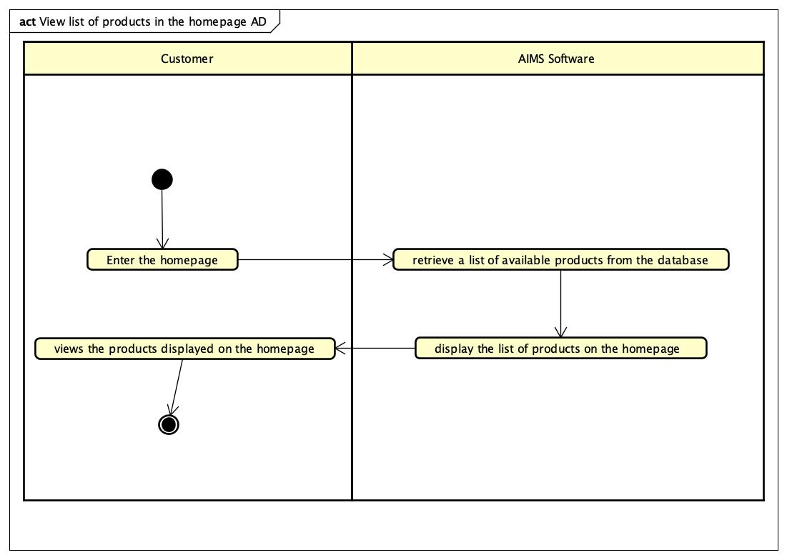

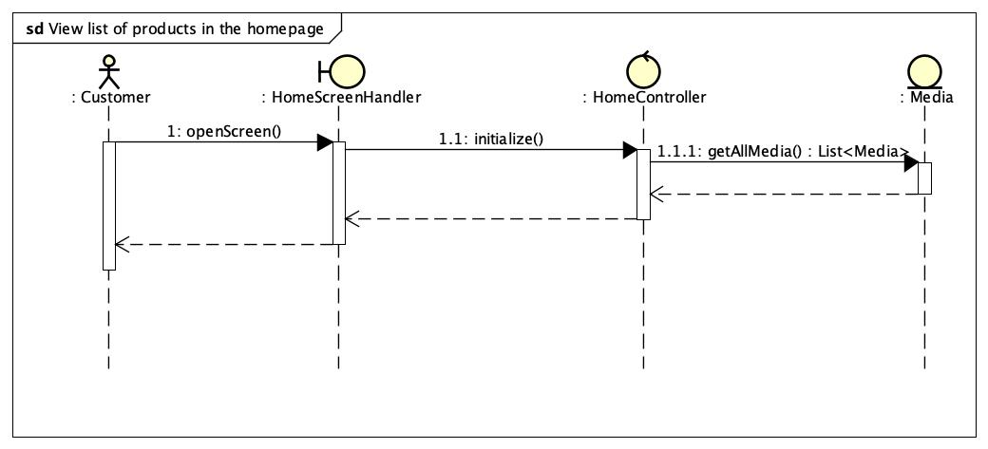

1. Log in

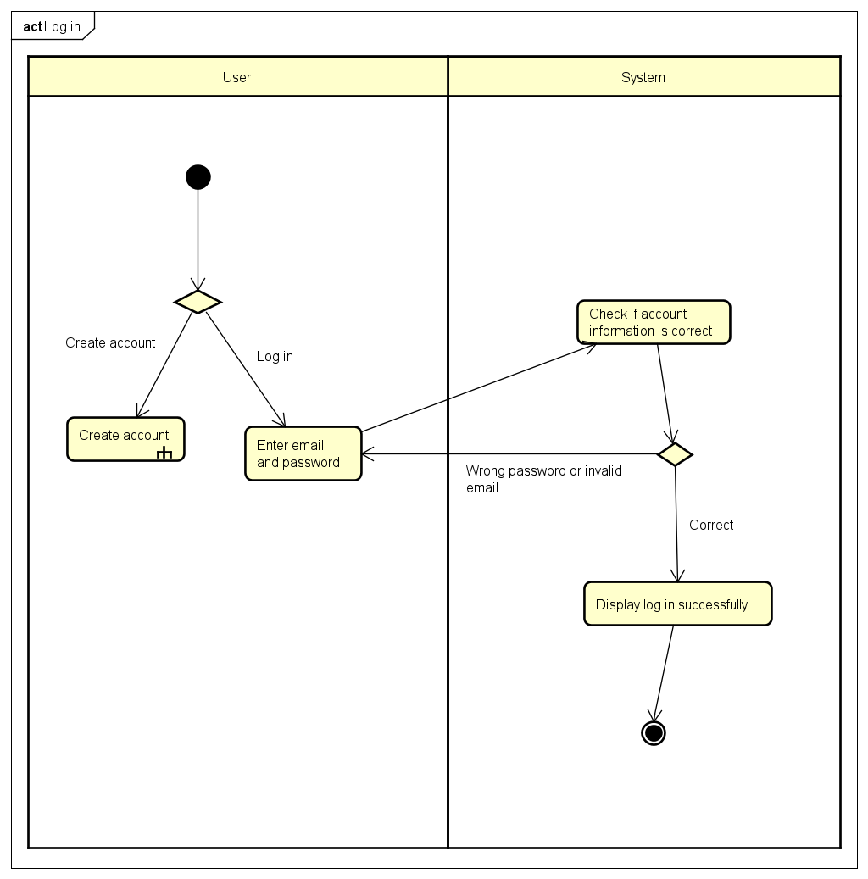

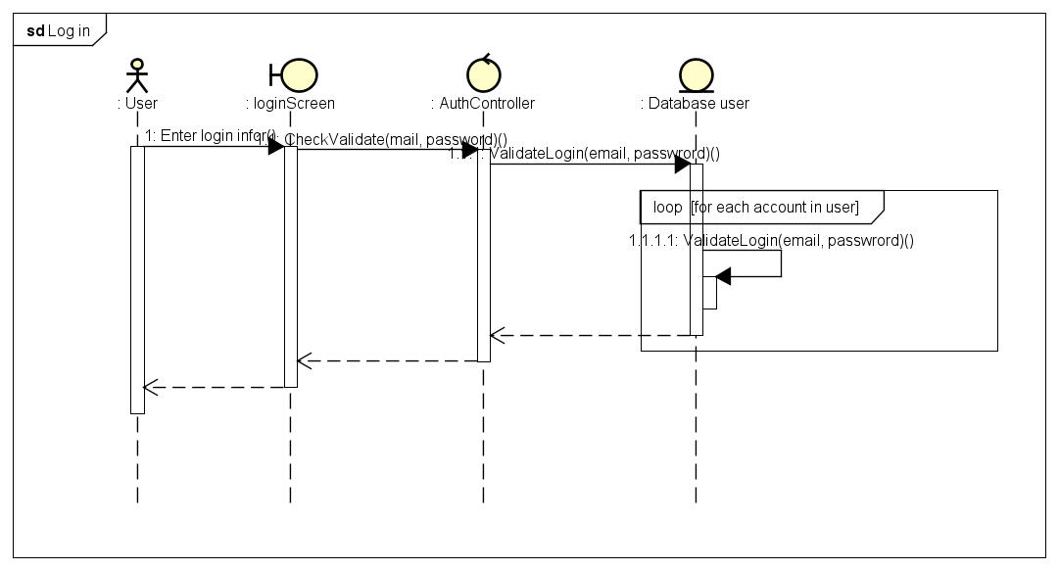

1. Change the access permission

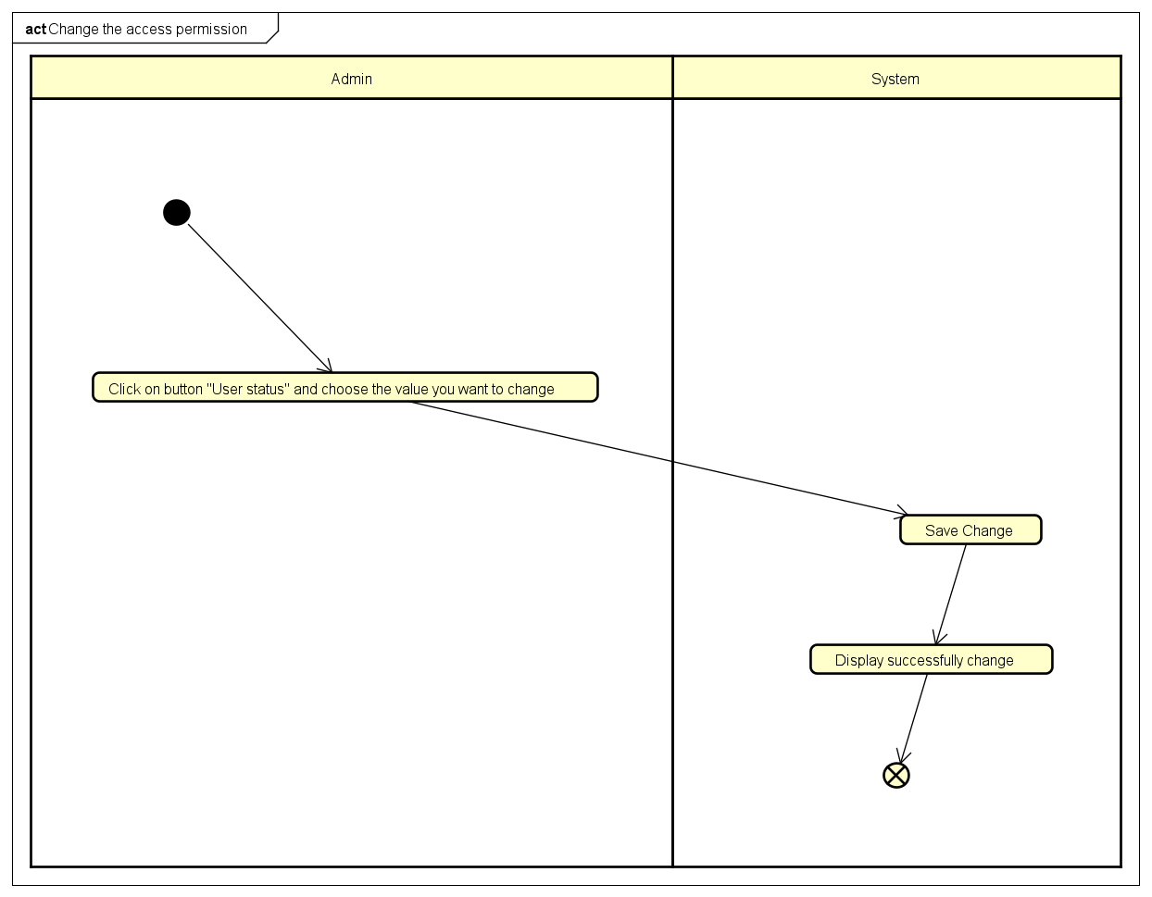

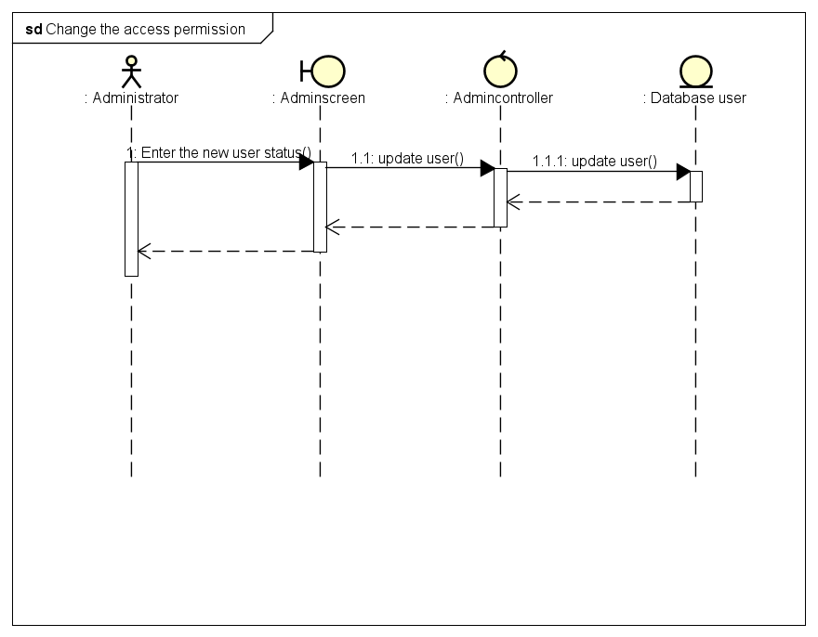

1. Change the user’s password

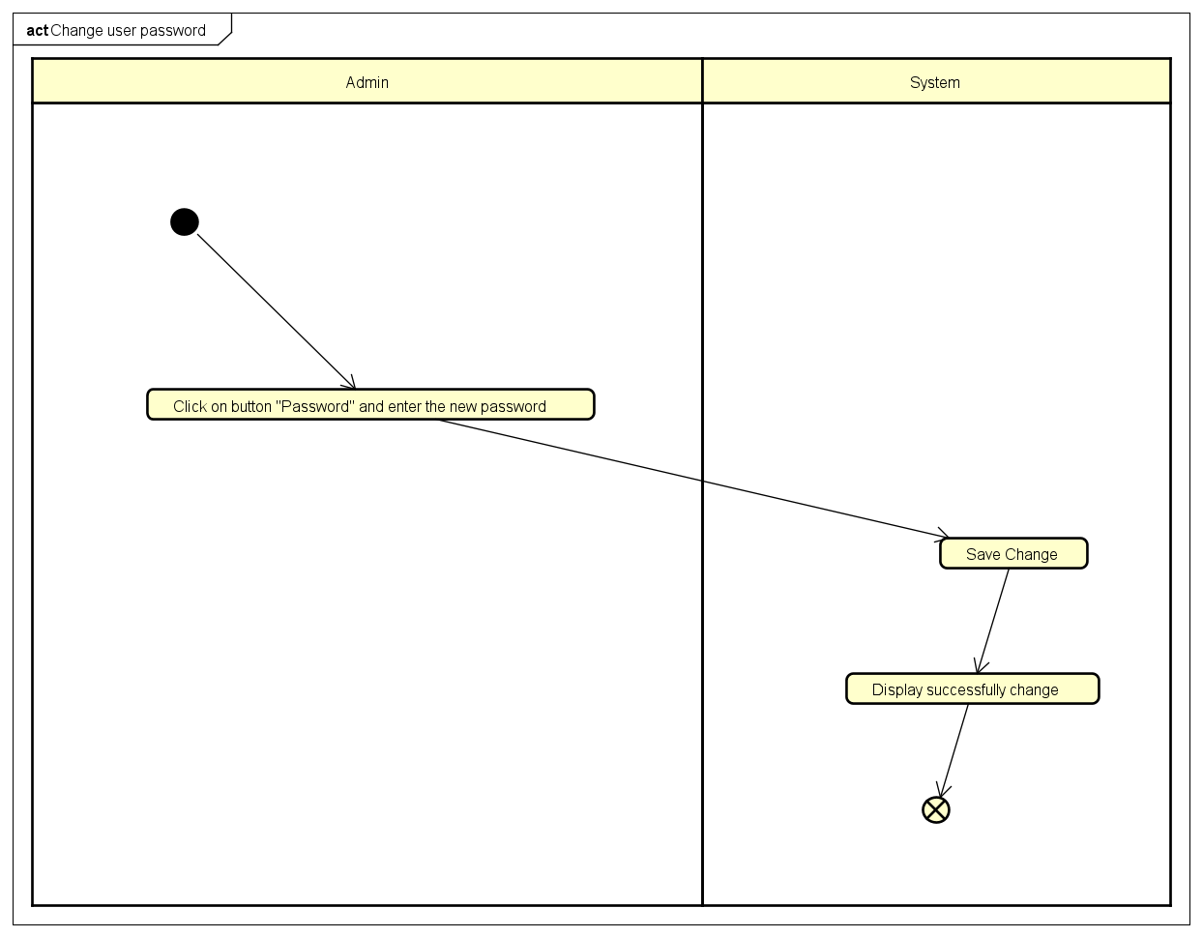

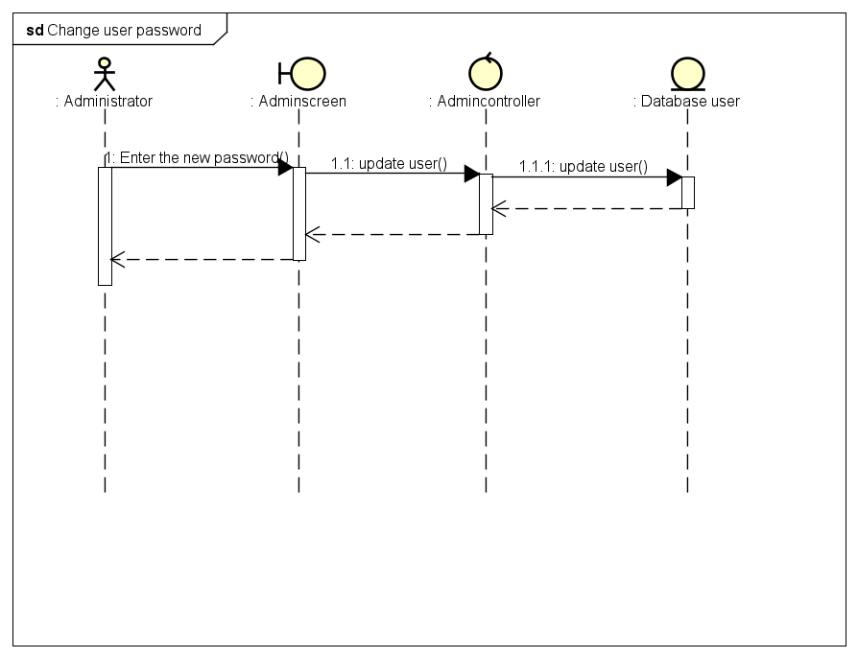

1. Manage user roles

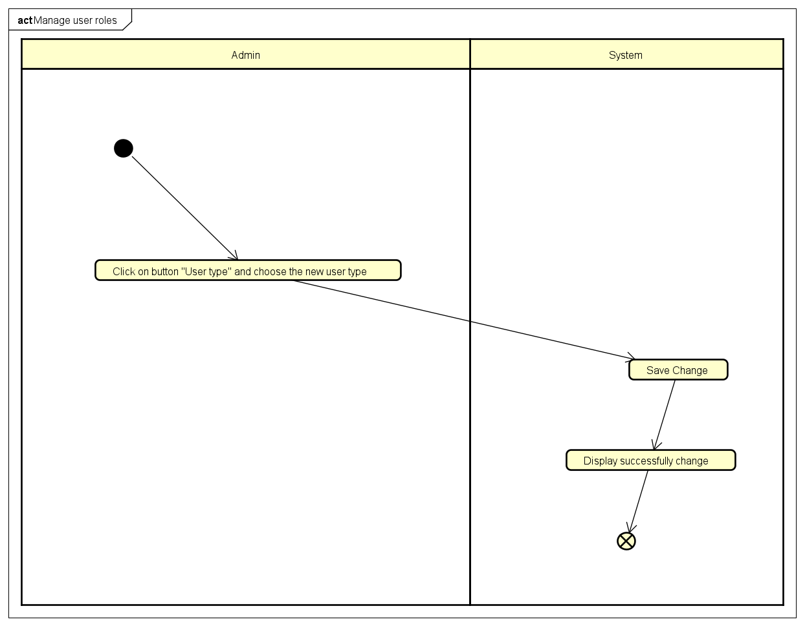

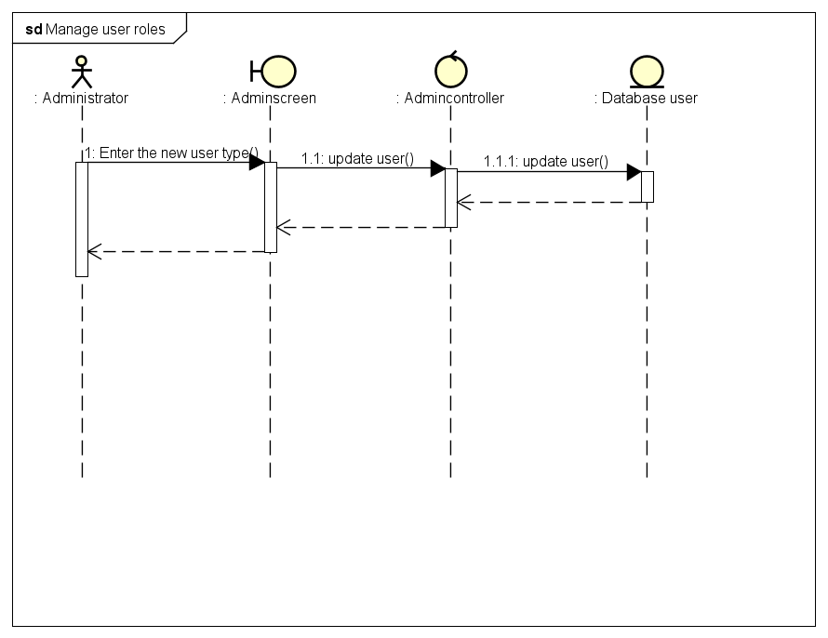

1. Create user

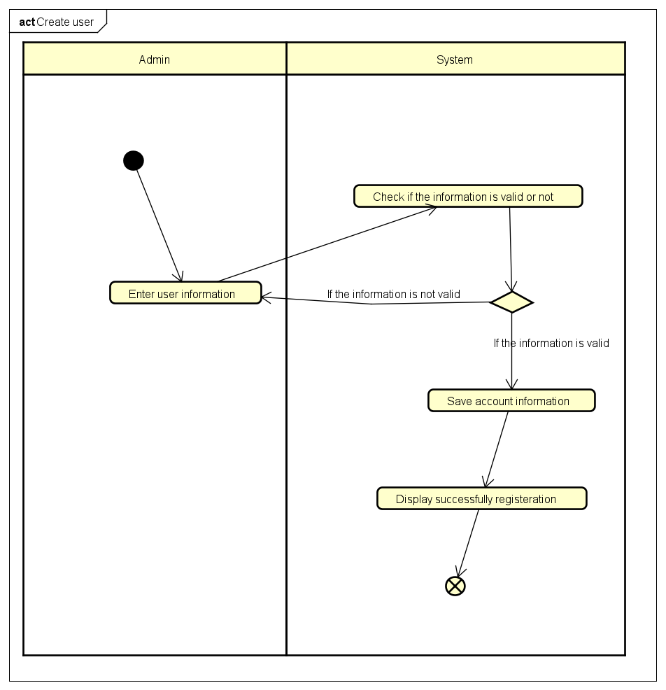

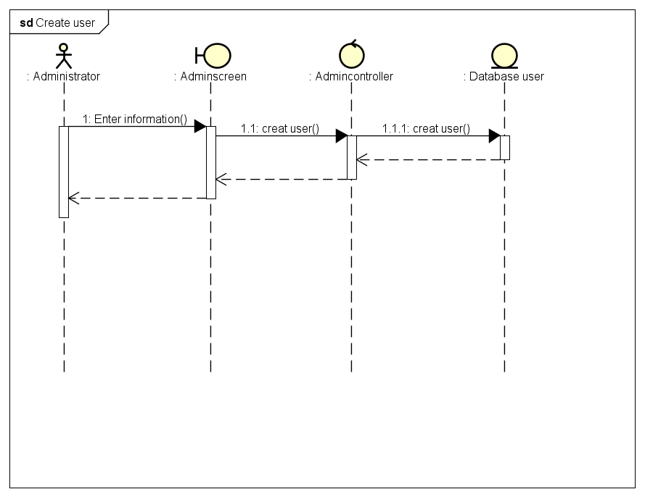

1. Read user

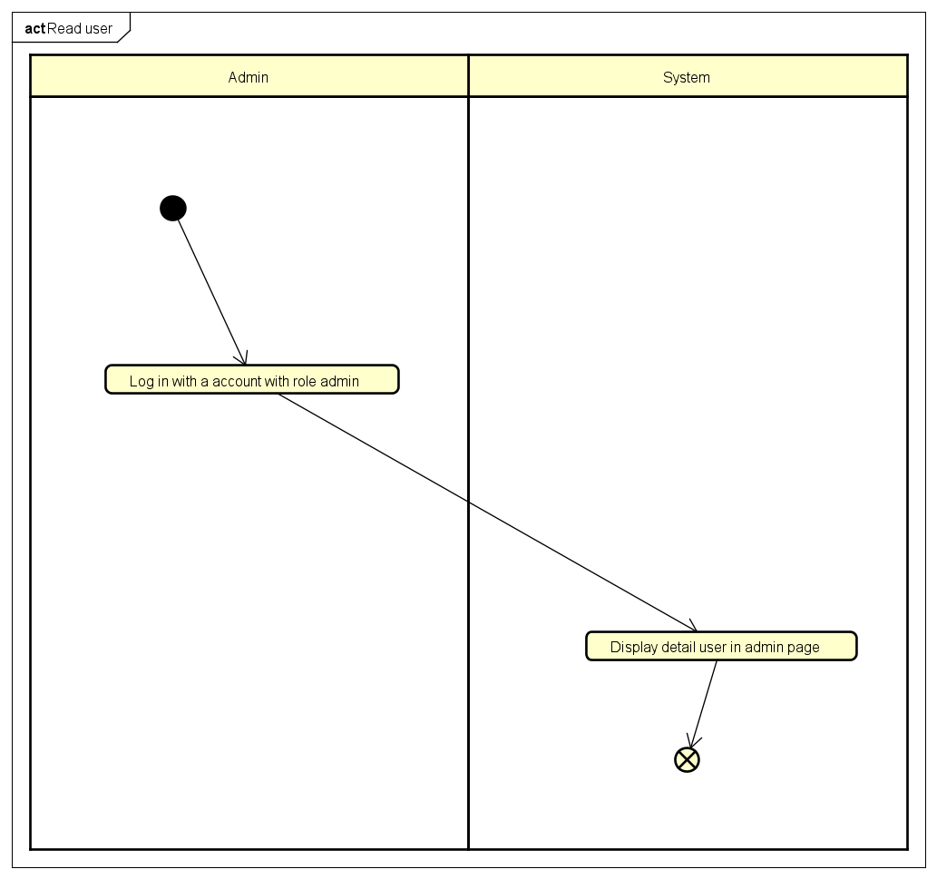

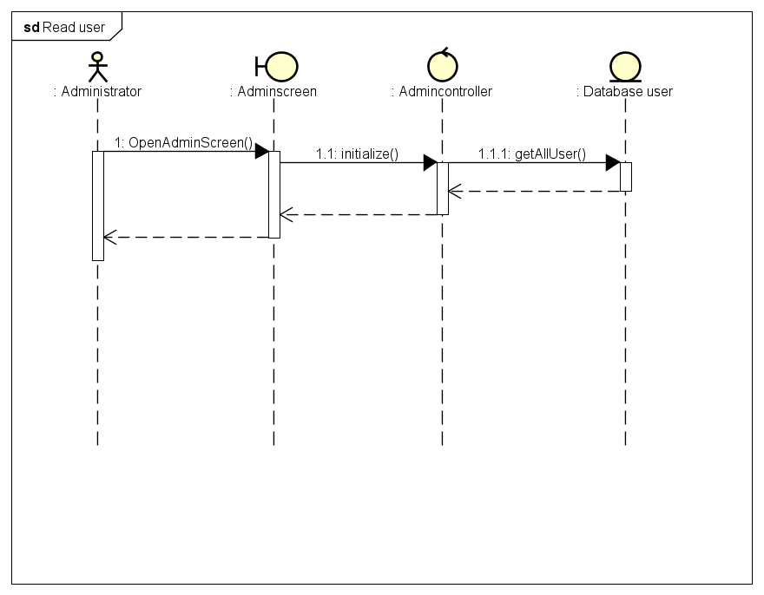

1. Update user

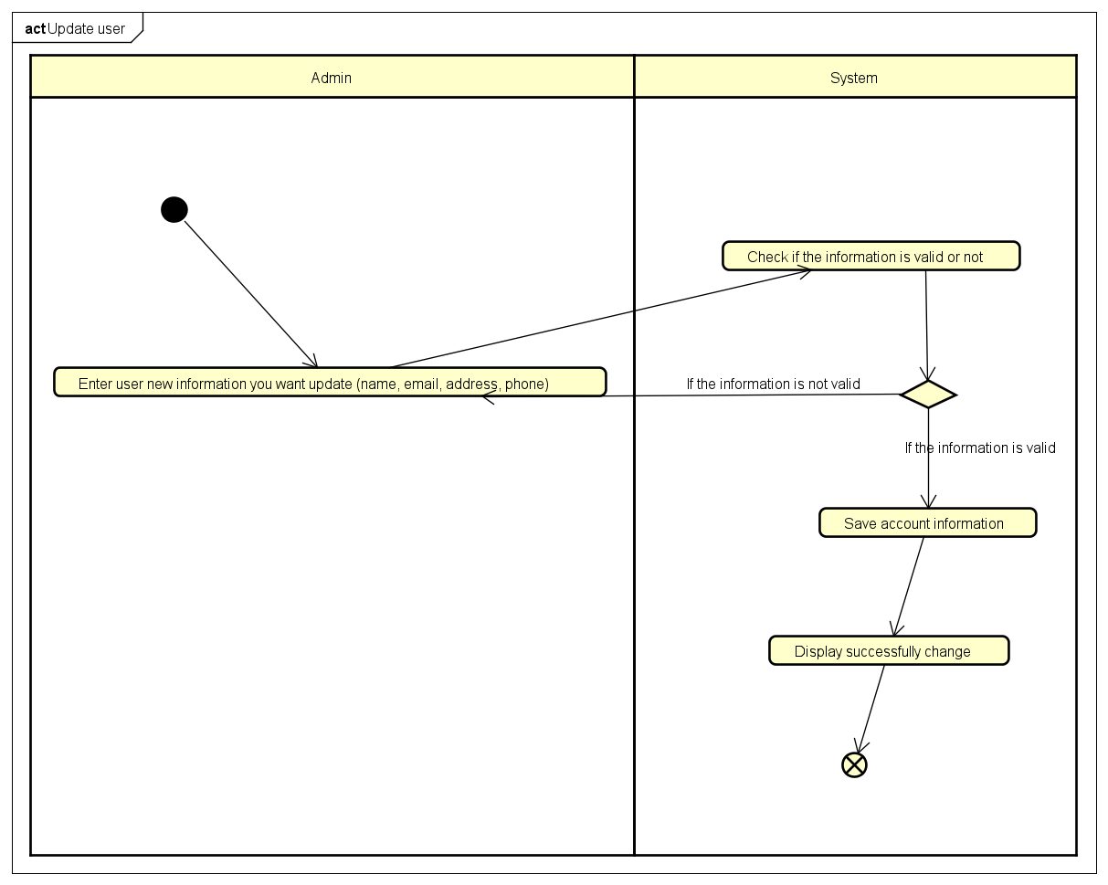

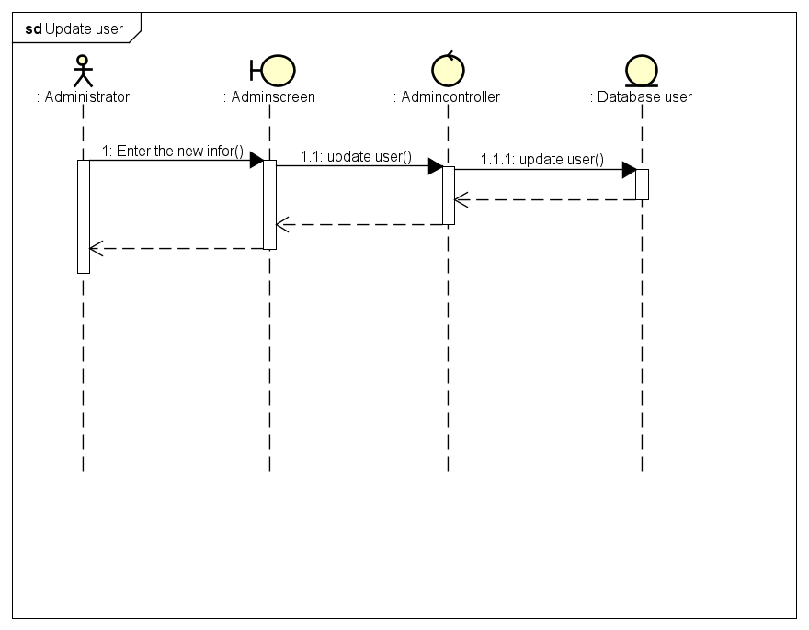

1. Delete use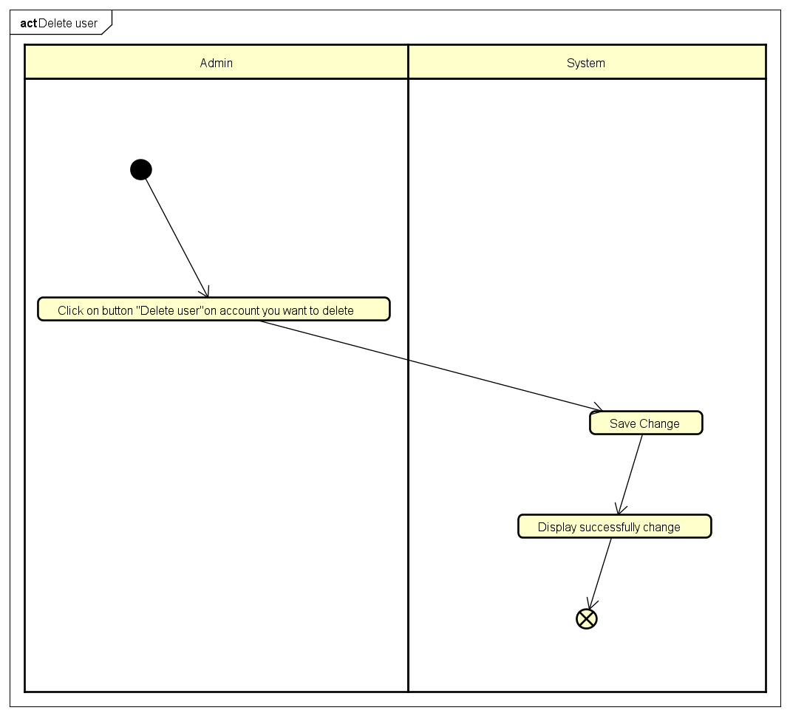

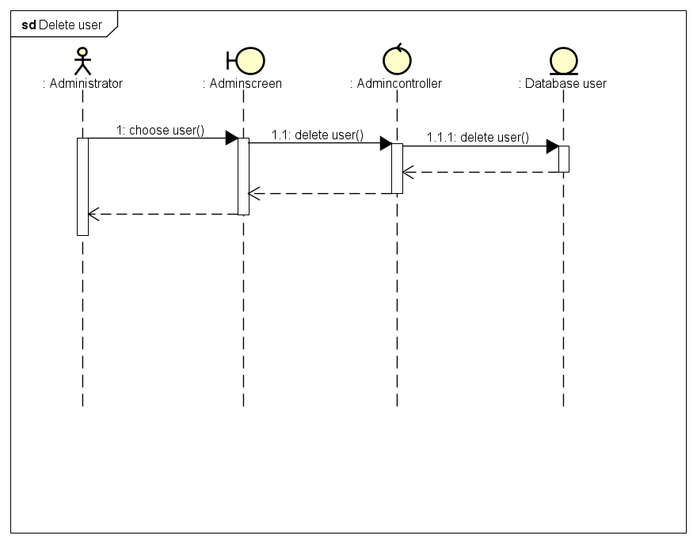

1. View order info

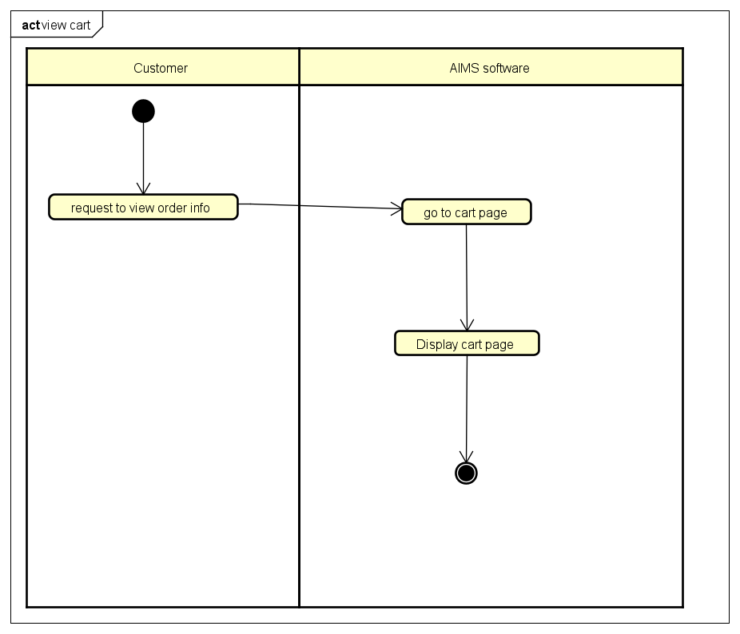

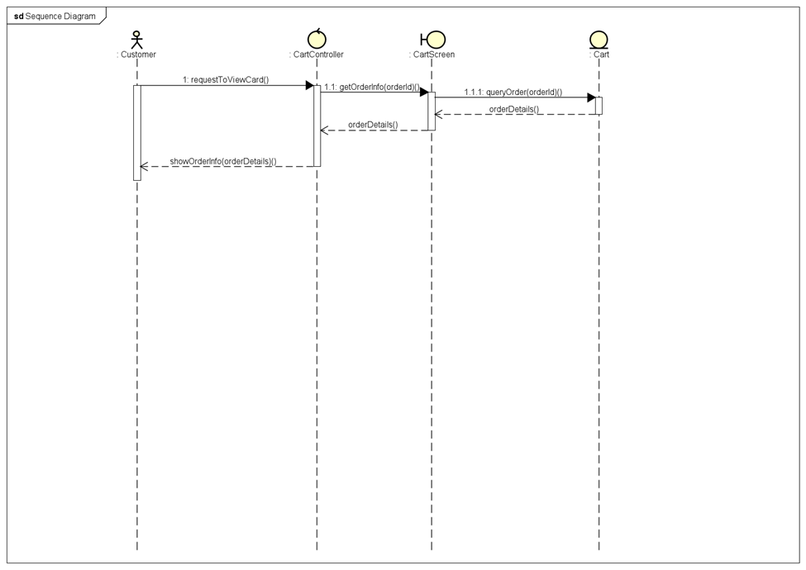

1. Place an order

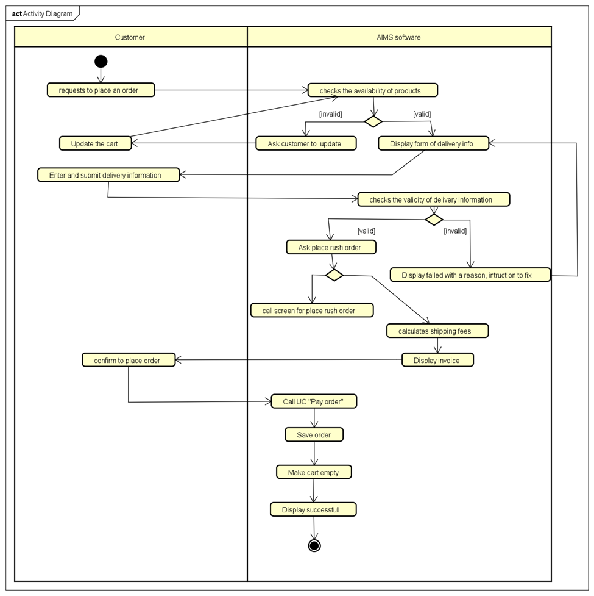

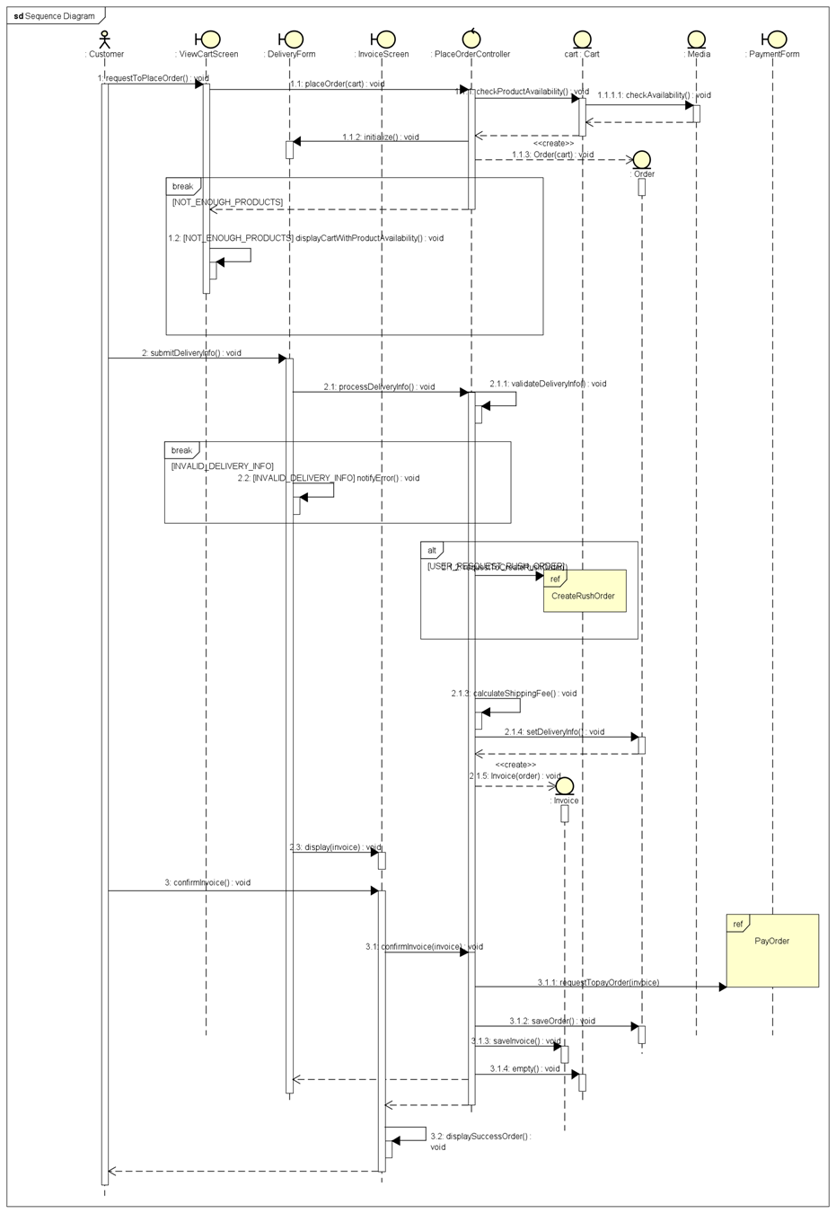

1. Place rush order

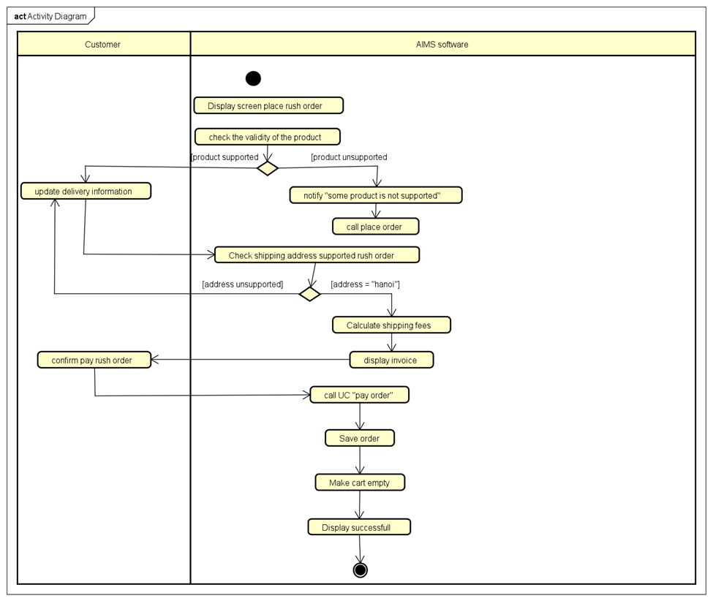

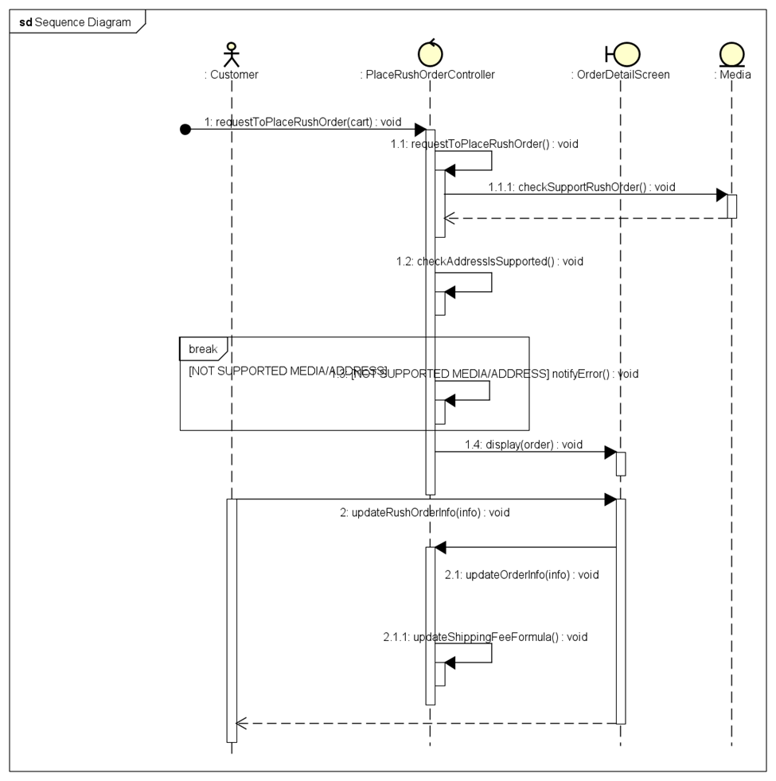

1. Pay order

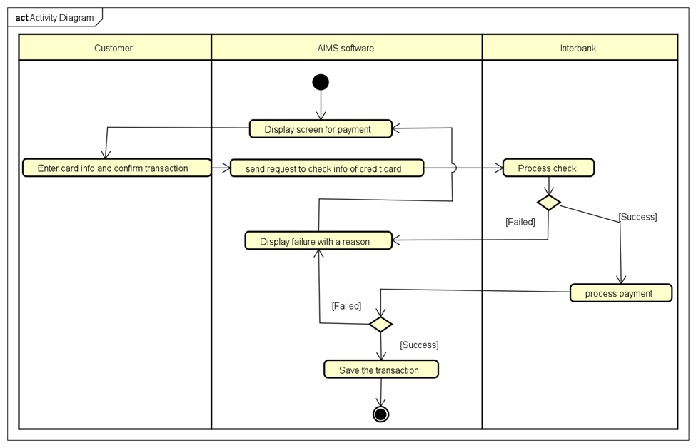



1. Cancel order



1. CRUD product

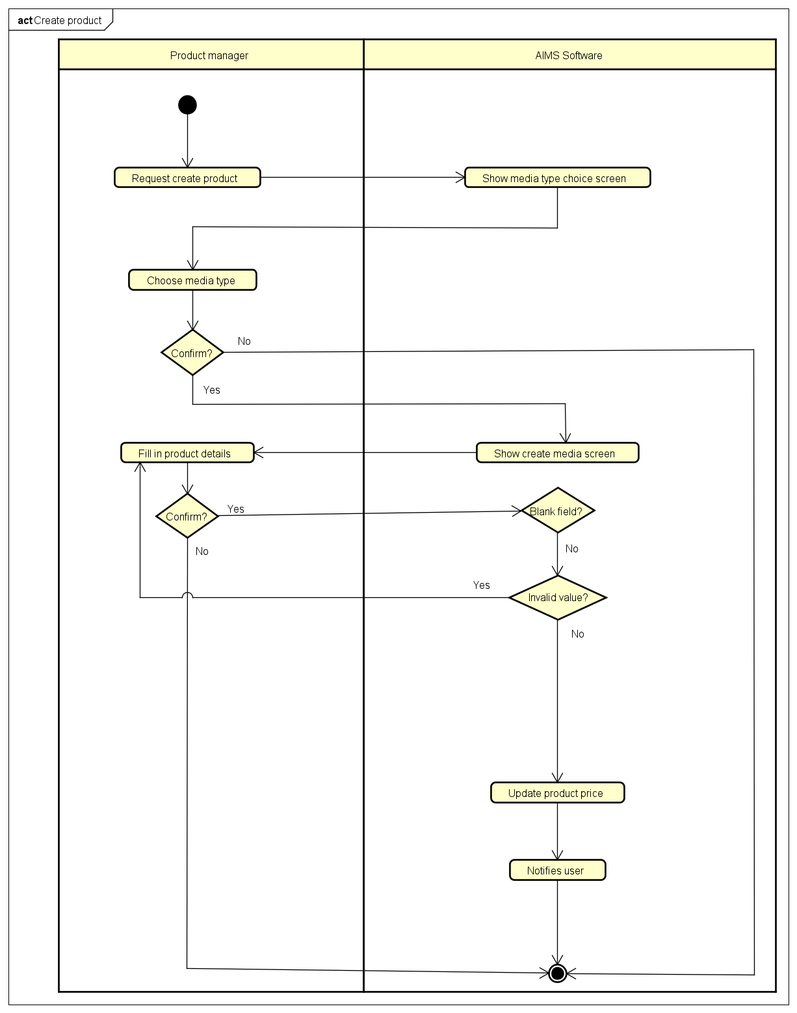

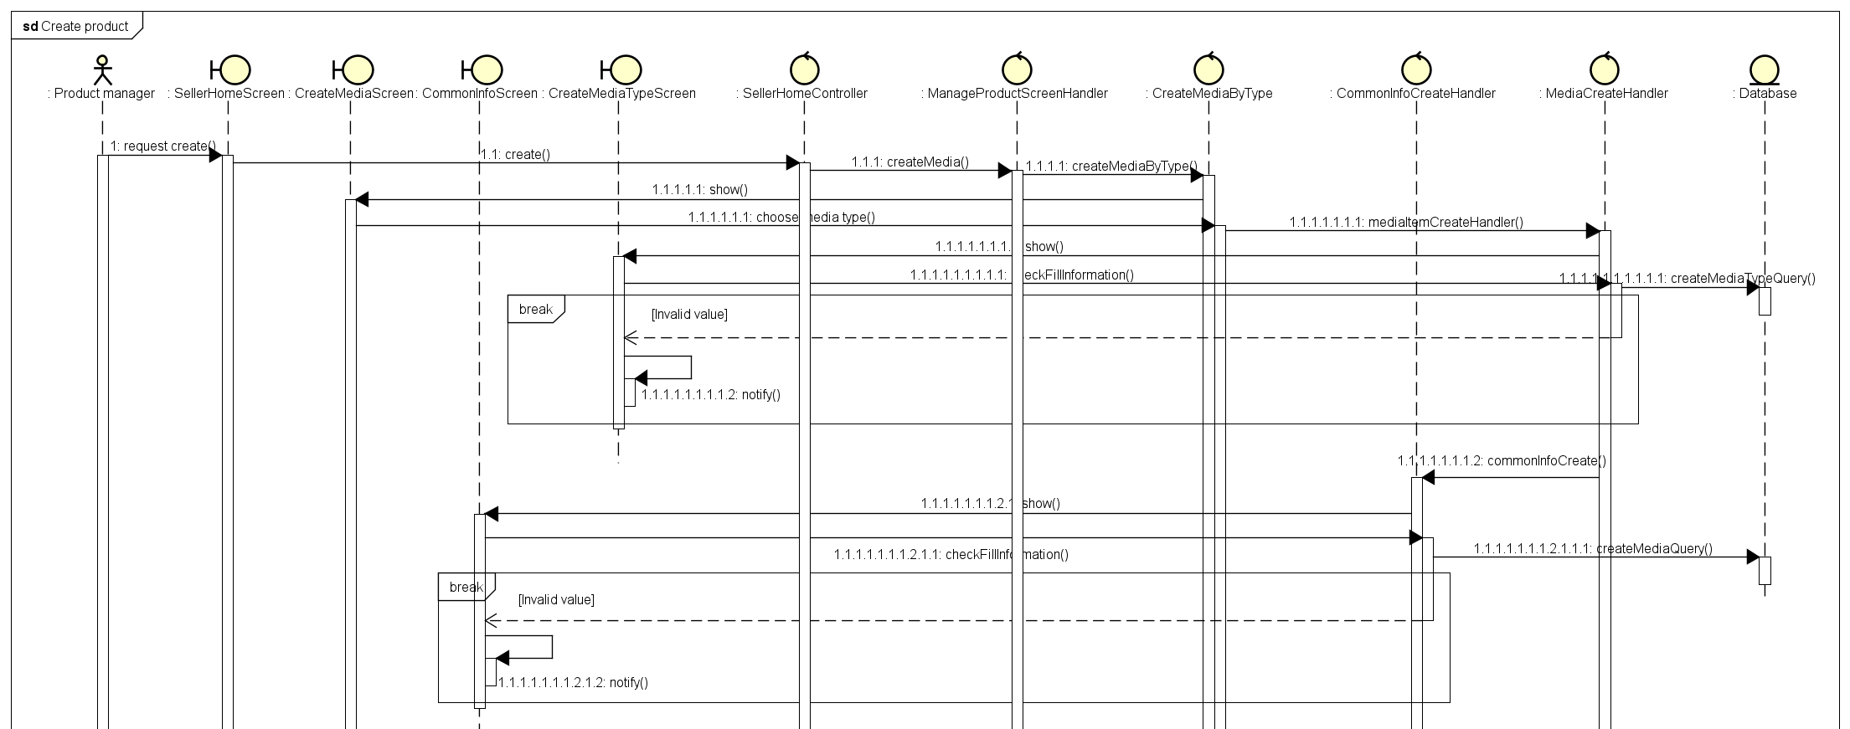

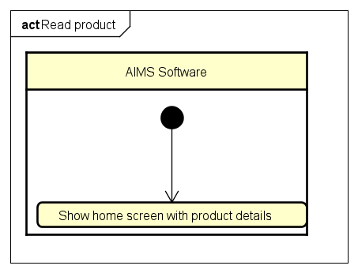

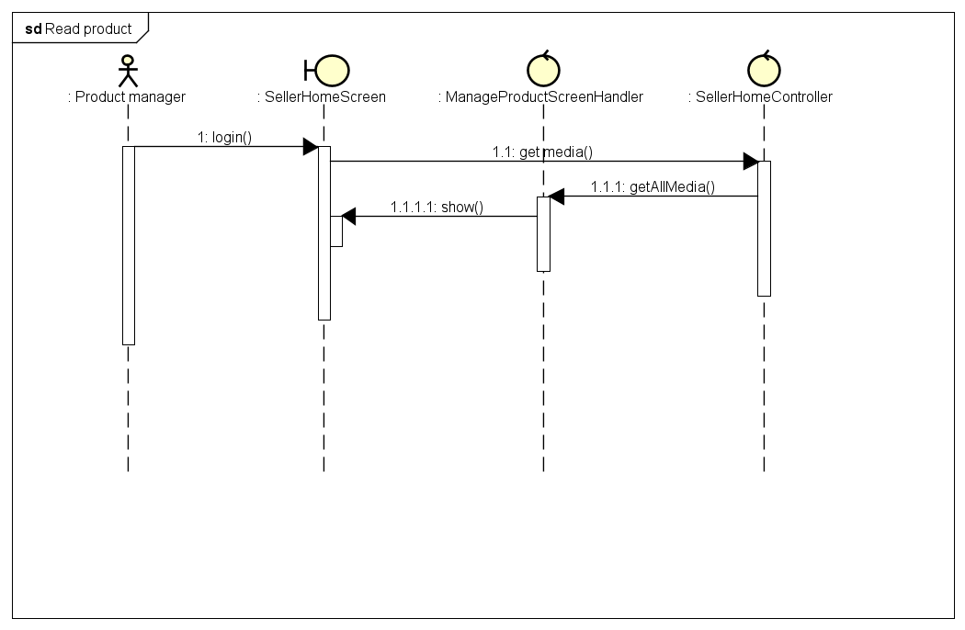

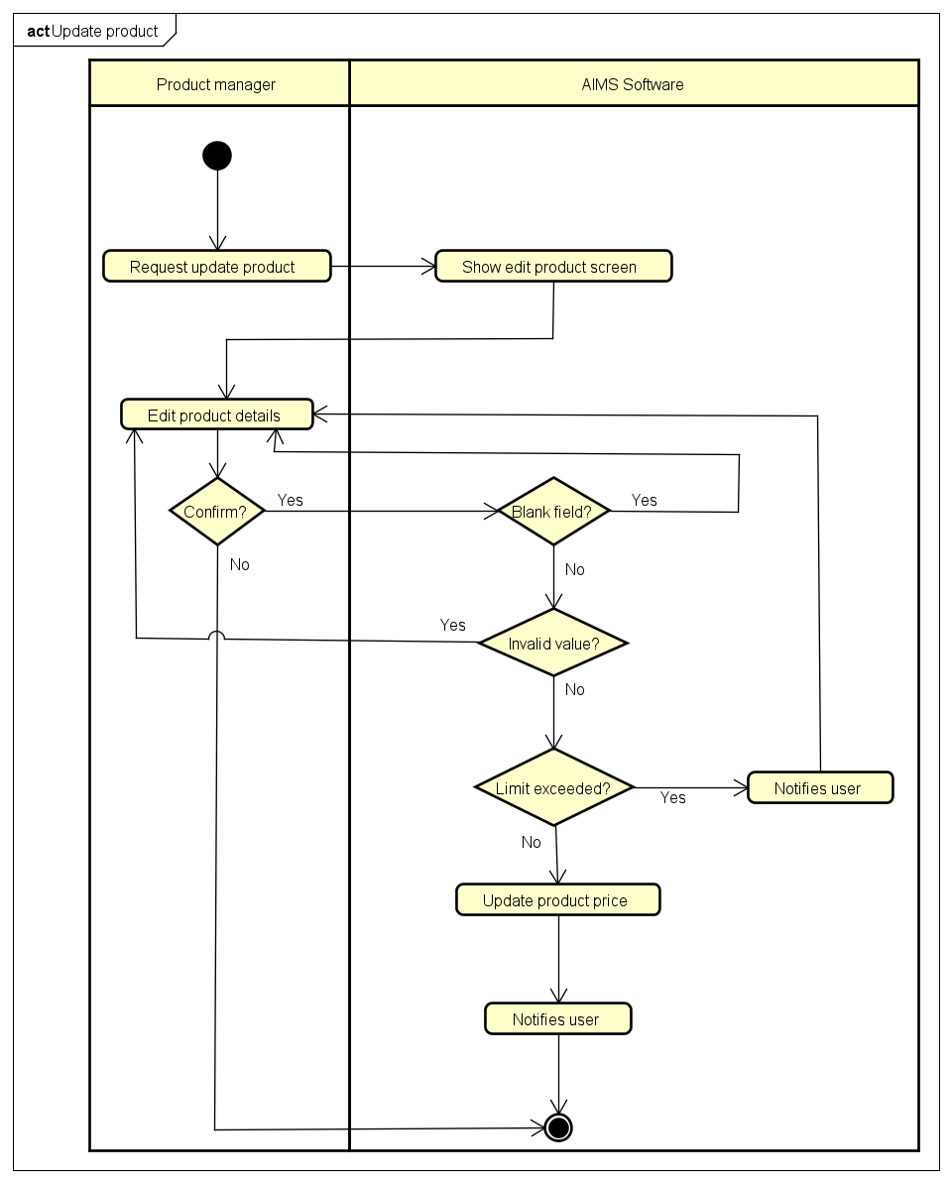

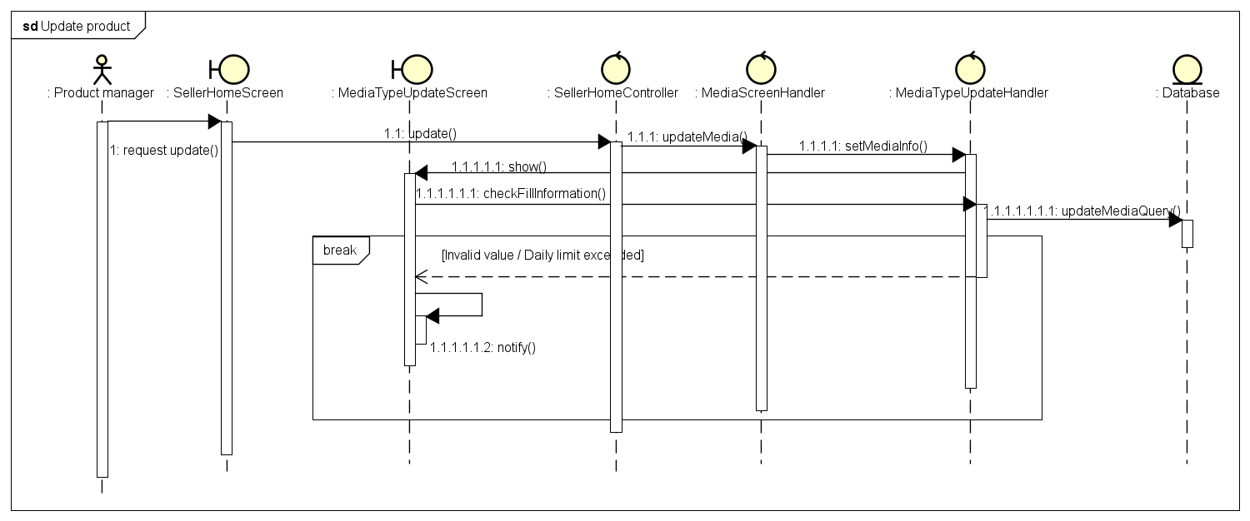

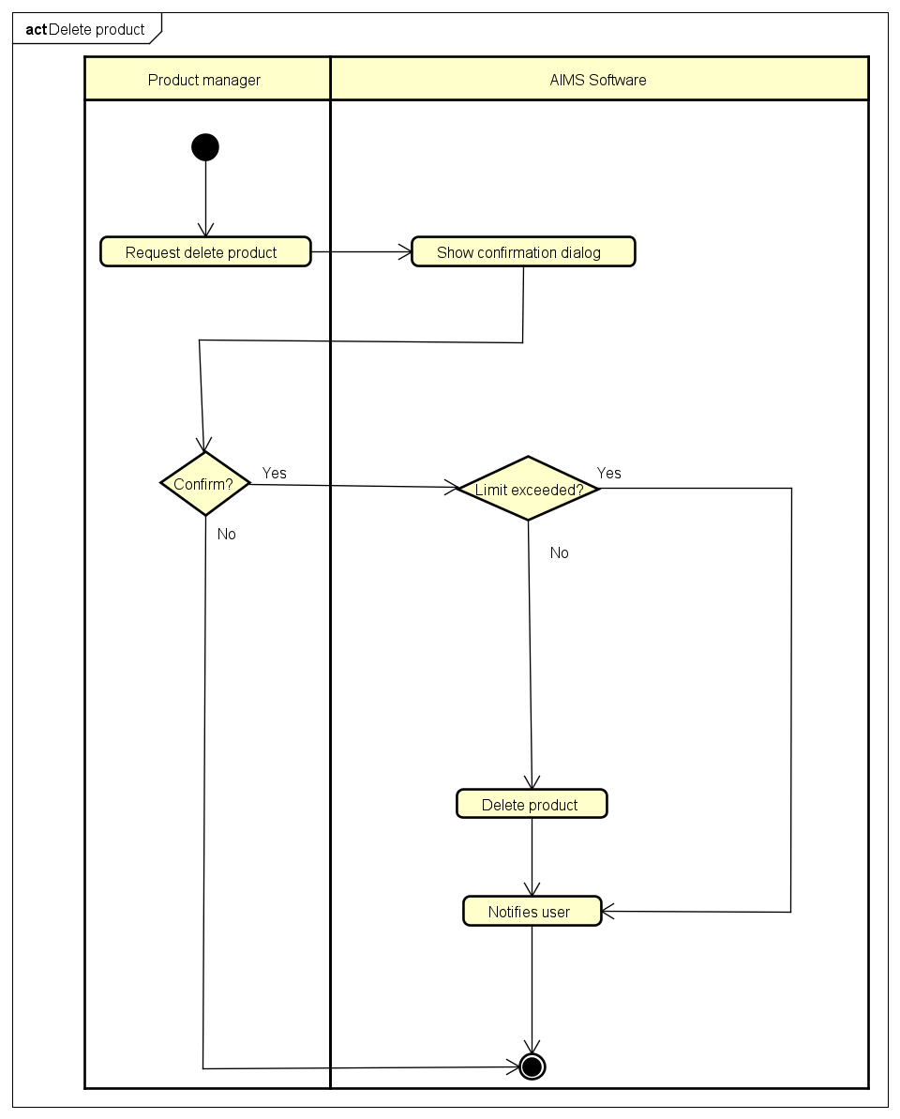

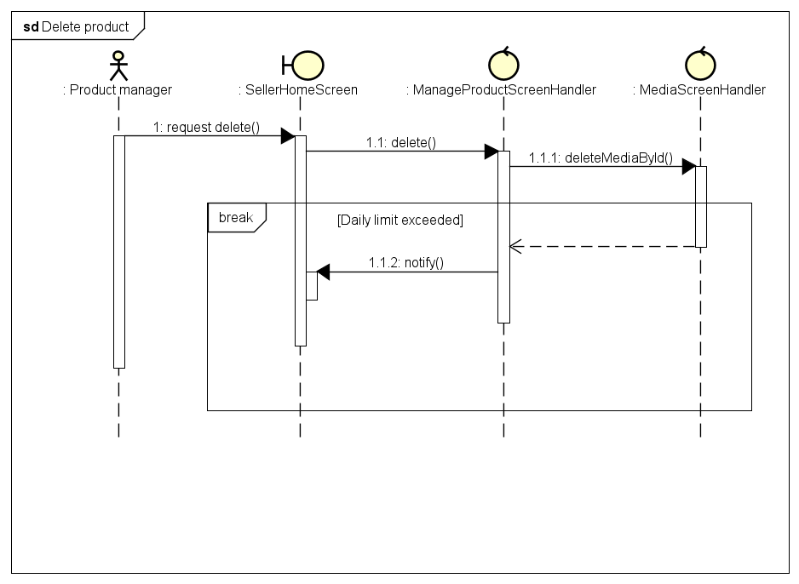

1. Update product price

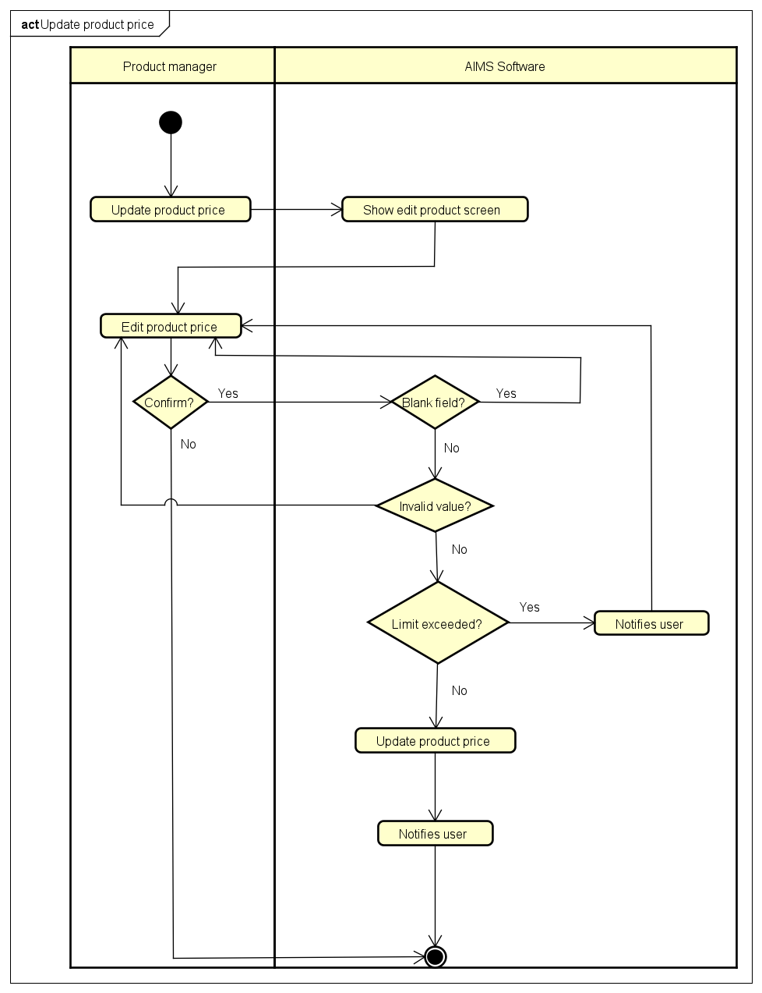

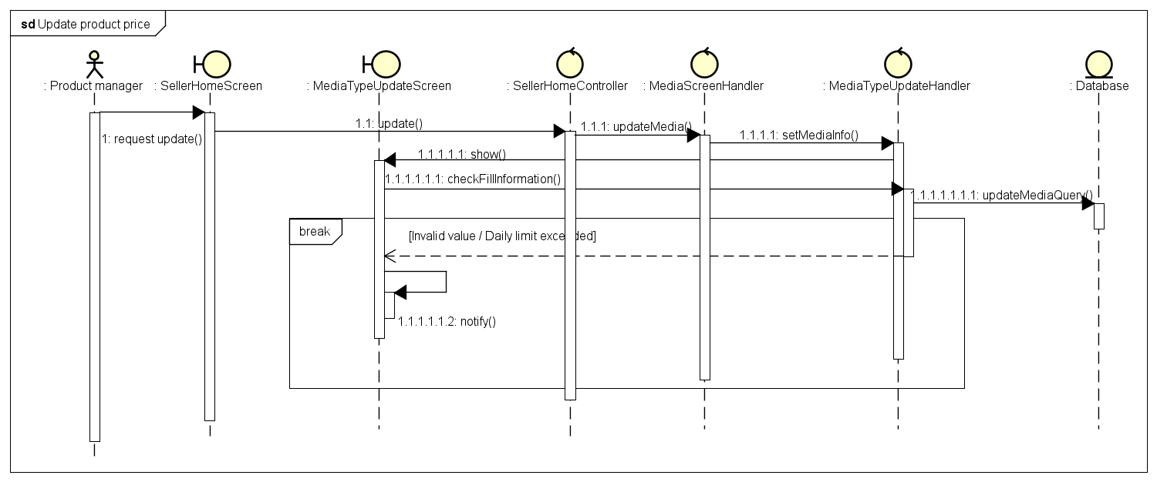

## Analysis Class Diagrams

## Unified Analysis Class Diagram

## Unified Analysis Class Diagram

*<Describe the software components and configuration supporting the security and privacy of the system. Specify the architecture for (1) authentication to validate user identity before allowing access to the system;(2) authorization of users to perform functional activity once logged into the system, (3) encryption protocol to support the business risks and the nature of information, and (4) logging and auditing design, if required.>*

# Detailed Design

## User Interface Design

### Screen Configuration Standardization

**Display**

Number of colors supported: 16,777,216 colors

Resolution: 1326 × 788 𝑝𝑖𝑥𝑒𝑙𝑠

**Screen**

Location of the messages: Starting from the top vertically and in the middle horizontally of the frame down to the bottom.

Display of the screen title: The title is located at the top of the frame in the left.

Consistency in expression of alphanumeric numbers: comma for separator of thousand while strings only consist of characters, digits, commas, dots, spaces, underscores, and hyphen symbol.

**Control**

Size of the text: medium size (mostly 24px). Font: Segoe UI. Color: #000000

Input check process: Should check if it is empty or not. Next, check if the input is in the correct format or not

Sequence of moving the focus: There will be no stack frames. Each screen will be separated. However, the manual is considered a popup message, as the main screen cannot be operated while the manual screen is shown. After the opening screen, the app will start with splash screen, and then the first screen (home screen) will appear.

**Direct input from the keyboard**

There will be no shortcuts. There are back buttons to move back to the previous screen. Also, there is the close button “X” located at the title bar to the right to close the screen.

**Error**

A message will be given to notify the users what is the problem.

### Screen Transition Diagrams

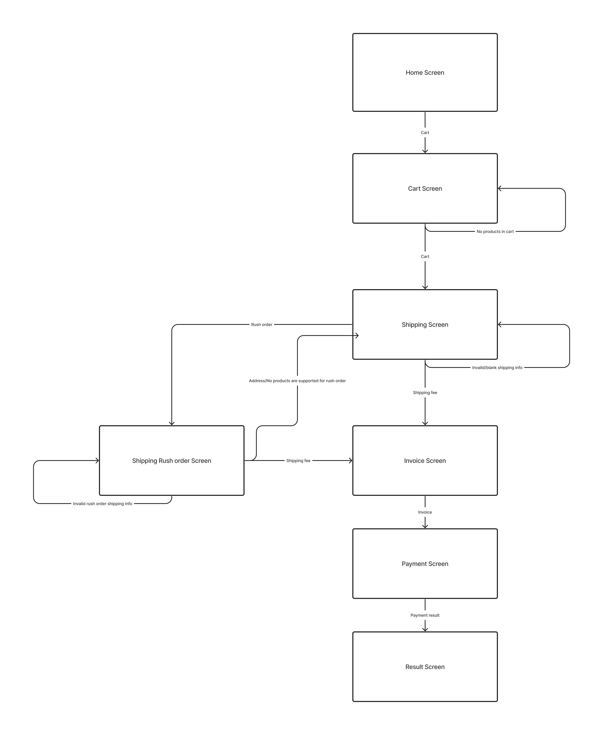

### 

### Screen Specifications

#### Shipping Screen

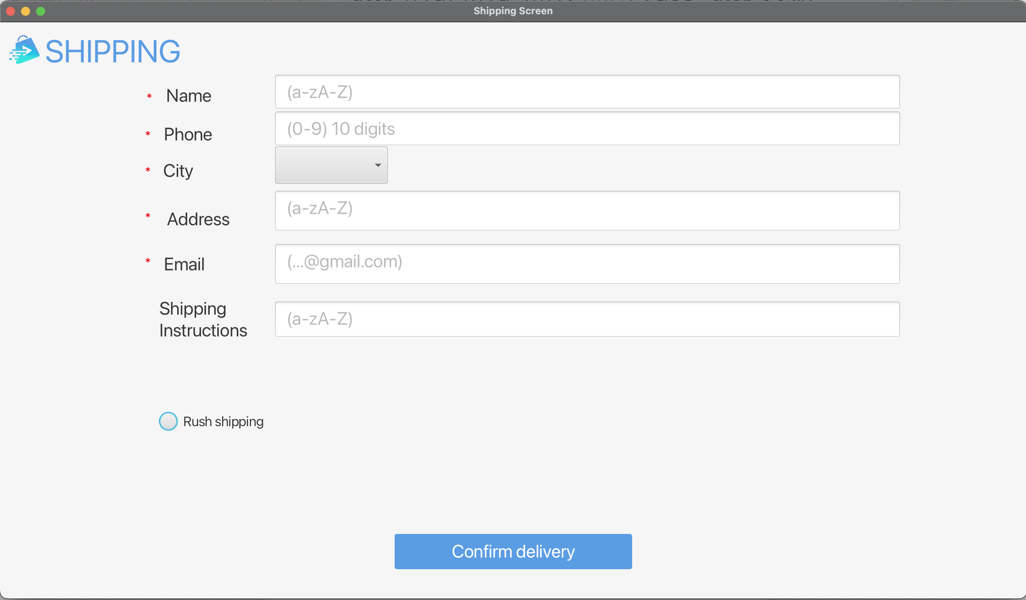

**Specification:**

|  |  |  |
| --- | --- | --- |
| **Control** | **Operation** | **Function** |
| Input delivery information | Input field | Input field for name, phone number, address, shipping instructions |
| Input delivery information | Dropdown | Select the province |
| Place rush order radio | Click | Chooses to place rush order |
| Confirm delivery button | Click | Chooses to place normal order |

#### Cart Screen

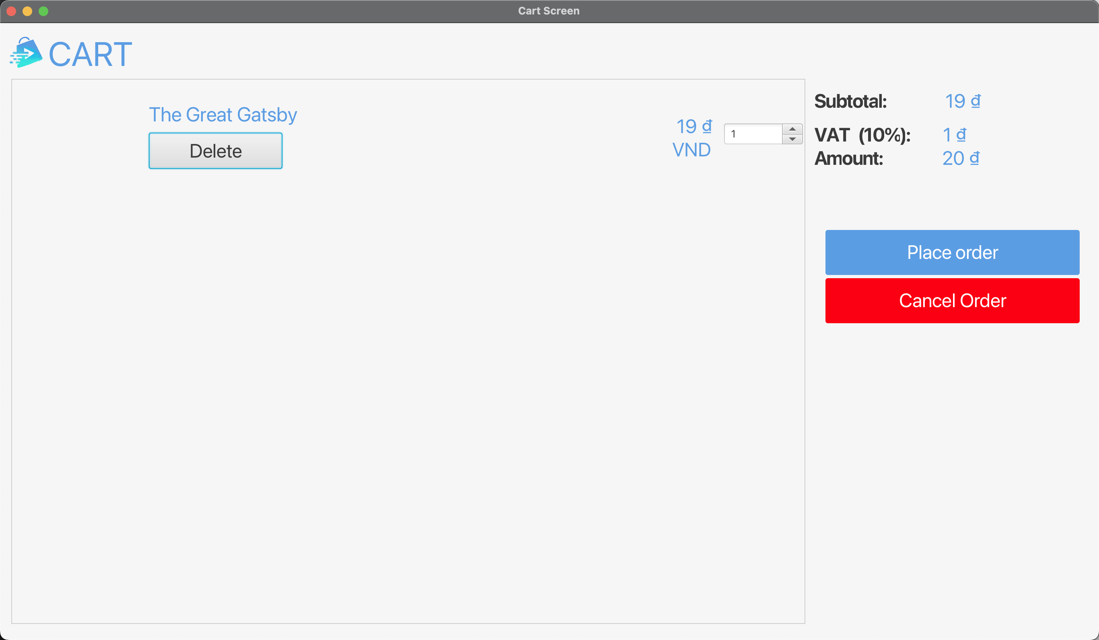

**Specification:**

|  |  |  |
| --- | --- | --- |
| **Control** | **Operation** | **Function** |
| Home button | Click | Display the home screen |
| Area for displaying the list of items in cart | Initial | Display the list of items in card |
| Area for displaying the order summary | Initial | Display the detail order information |
| Quantity input | Input field | Change the number of items |
| Delete button | Click | Remove the item from the cart |
| Place order button | Click | Display the delivery form screen |

**Field attributes:**

|  |  |  |  |  |
| --- | --- | --- | --- | --- |
| **Item name** | **Number of digit (bytes)** | **Type** | **Field attribute** | **Remarks** |
| The number of items in cart | 20 | Numeral | Black | Left-justified |
| Item title | 50 | Character | Black | Left-justified |
| Price of each item | 20 | Numeral | Green | Left-justified |
| Total price of each item | 20 | Numeral | Black | Left-justified |
| Subtotal | 20 | Numeral | Black | Left-justified |
| Tax | 20 | Numeral | Black | Left-justified |
| Total | 20 | Numeral | Black | Left-justified |

#### Home Screen:

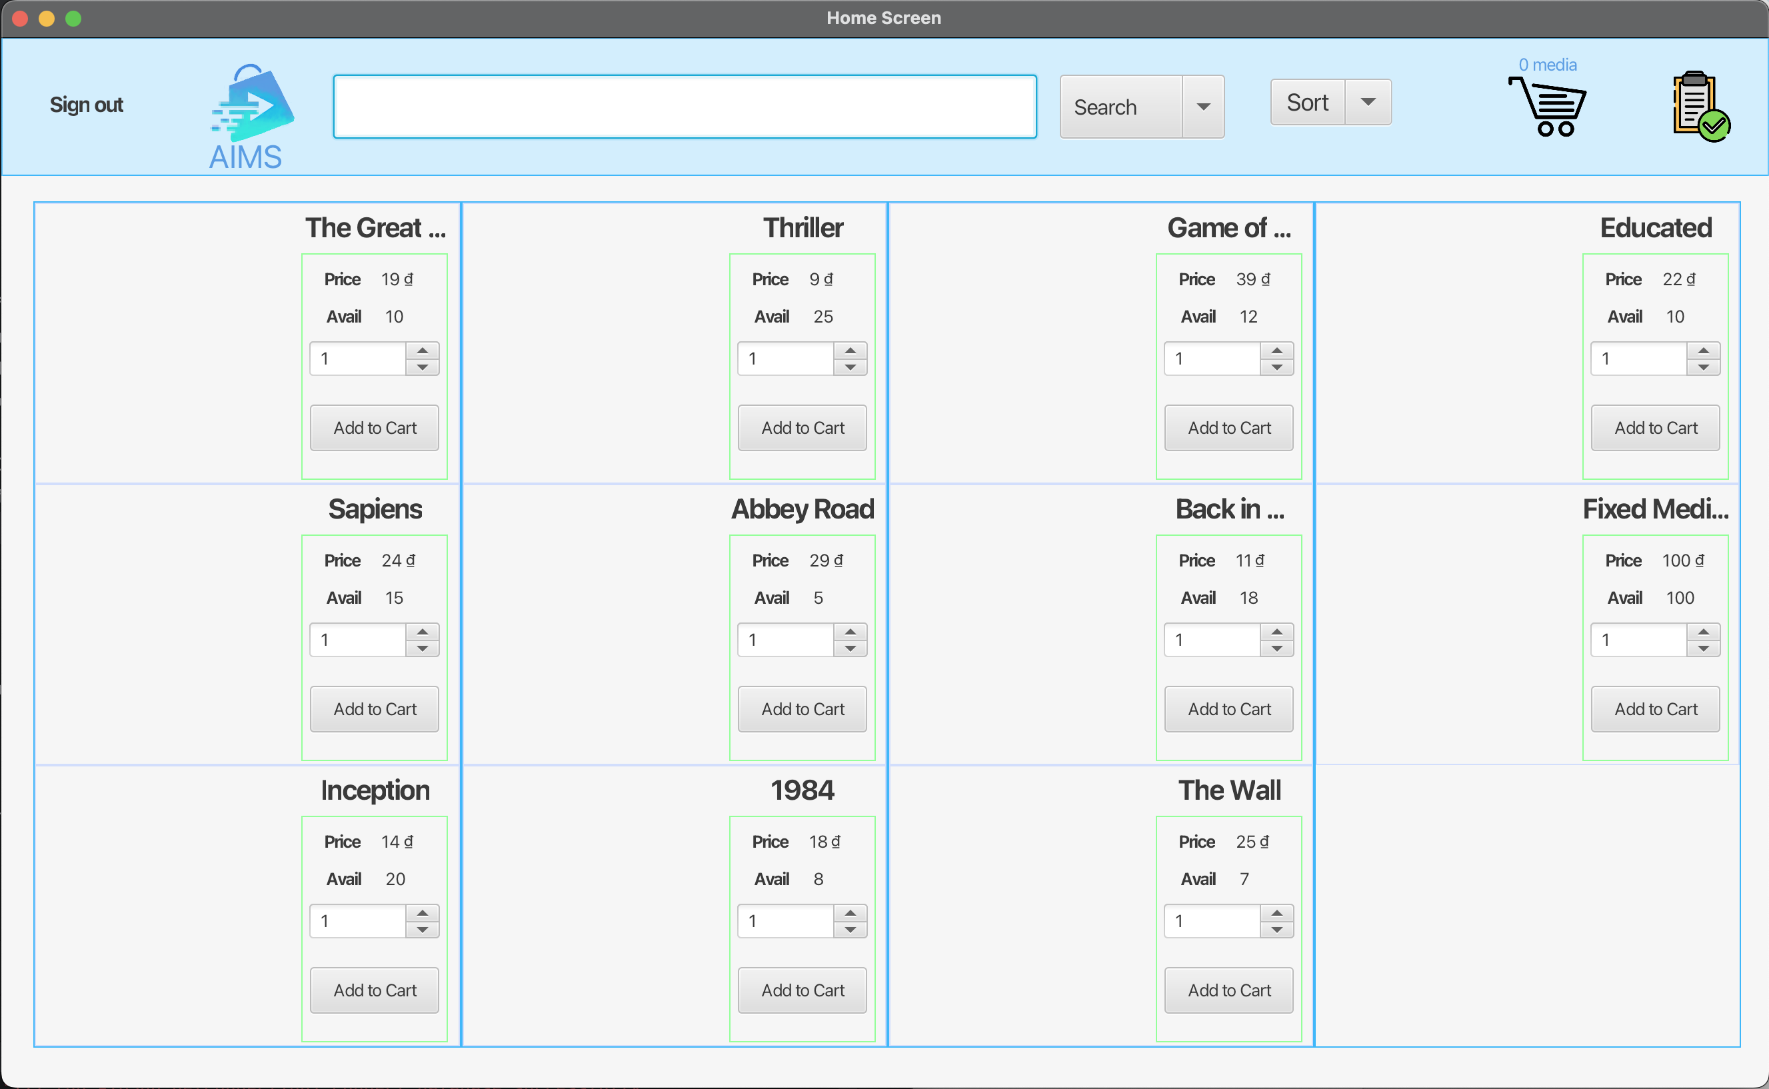

**Specification:**

|  |  |  |
| --- | --- | --- |
| **Control** | **Operation** | **Function** |
| Cart button | Click | Display the cart screen |
| Save cart button | Click | Save the cart to the database for later retrieval |
| Search | Input field | Search item |
| Search button | Click | Display the list of products that match your search criteria |
| Sort button | Click | Based on the product’s title/ product’s price, display the list of products in ascending order |
| Area for displaying the list of products | Initial | Display the list of products |
| Incrementer/ Decrementer | Click | Change the amount of products can be added to cart |
| Add to cart button | Click | Add the product to cart |

**Field attributes:**

|  |  |  |  |  |
| --- | --- | --- | --- | --- |
| **Item name** | **Number of digit (bytes)** | **Type** | **Field attribute** | **Remarks** |
| Product title | 50 | Character | Green | Left-justified |
| Price | 20 | Numeral | Green | Left-justified |
| Avail | 20 | Numeral | Green | Left-justified |
| The number of products in cart | 20 | Numeral | White |  |

## Data Modeling

### Conceptual Data Modeling

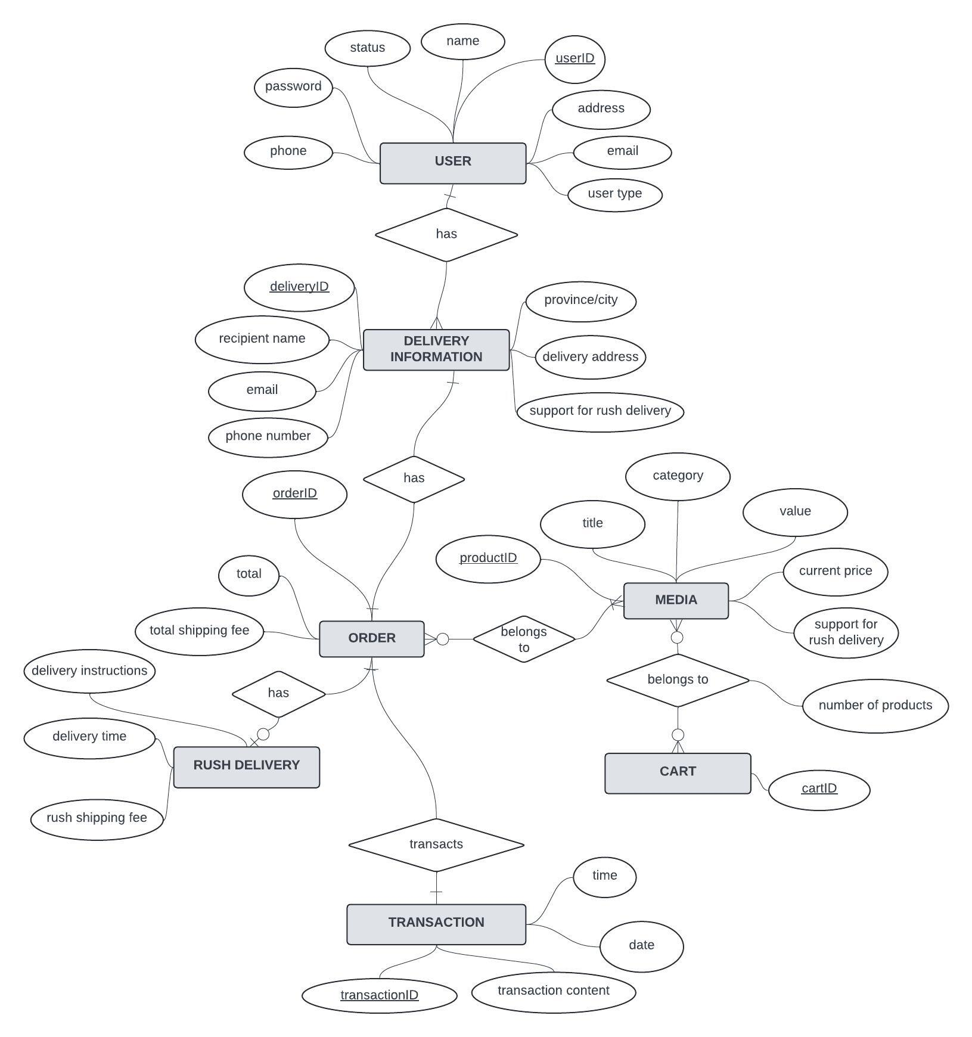

*The central entity is USER, which has attributes like name, userId, address, email, and user type. A USER entity can have many DELIVERY INFORMATION.*

*DELIVERY INFORMATION - Contains delivery details like recipient name, email, phone number, address, delivery instructions and time. Each can only belong to one USER and one ORDER.*

*ORDER - Represents an order placed by a user. It has an ID and ordering-related attributes (total amount, total shipping fee). Each ORDER has only one DELIVERY INFORMATION, can have at least one MEDIA and if the customer checks out, each ORDER will become a TRANSACTION.*

*MEDIA - Represents products available for purchase. Has attributes for title, productID, category, value (price), current price, and whether rush delivery is supported. Each MEDIA can or cannot belong to any ORDER or CART.*

*CART - Contains products a user has added to their shopping cart. Each CART can be empty or can contain many MEDIA.*

*TRANSACTION - Represents the transaction to complete an order. Linked to one ORDER and has attributes for transaction ID, time, and transaction content.*

*RUSH DELIVERY - Represents expedited shipping option, with attribute for rush shipping fee. An ORDER can have one or none RUSH DELIVERY.*

### Database Design

#### Database Management System

The chosen DBMS for this project is SQLite.

SQLite is a lightweight, file-based, and self-contained relational database management system (RDBMS). It is designed to be embedded into applications, making it a popular choice for local/client storage in application software such as web browsers, mobile devices, and desktop applications. Here are some key characteristics of SQLite:

* Serverless: SQLite does not require a separate server process. It reads and writes directly to ordinary disk files.
* Zero Configuration: SQLite does not need any configuration files or setup procedures. It is ready to use out of the box.
* Transactional: All transactions in SQLite are fully ACID-compliant (Atomic, Consistent, Isolated, and Durable), ensuring data integrity.
* Lightweight: SQLite has a small memory footprint and is suitable for resource-constrained devices and embedded systems.
* Cross-platform: SQLite is available on a wide range of operating systems, including Windows, macOS, Linux, iOS, and Android.
* Self-contained: An SQLite database is stored in a single file on disk, making it easy to transfer and backup.
* SQL Support: SQLite uses a subset of the SQL standard for querying and manipulating data. It supports most of the core SQL commands.
* Multiple Interfaces: SQLite provides APIs for various programming languages, including C, C++, Java, Python, and more.
* Public Domain: SQLite is open-source and falls under the public domain, allowing free use for any purpose, commercial or private.
* Concurrency: SQLite supports concurrent access to the database file by multiple processes or threads, with each connection having its own private cache space.

SQLite is often used as a local data store for applications, as an application file format, for website databases, and for testing and prototyping purposes. Its simplicity, portability, and low overhead make it a versatile choice for many software projects. However, it may not be suitable for large-scale, high-volume, or high-concurrency applications that require the full features and performance of a client/server database system.

#### Database Diagram

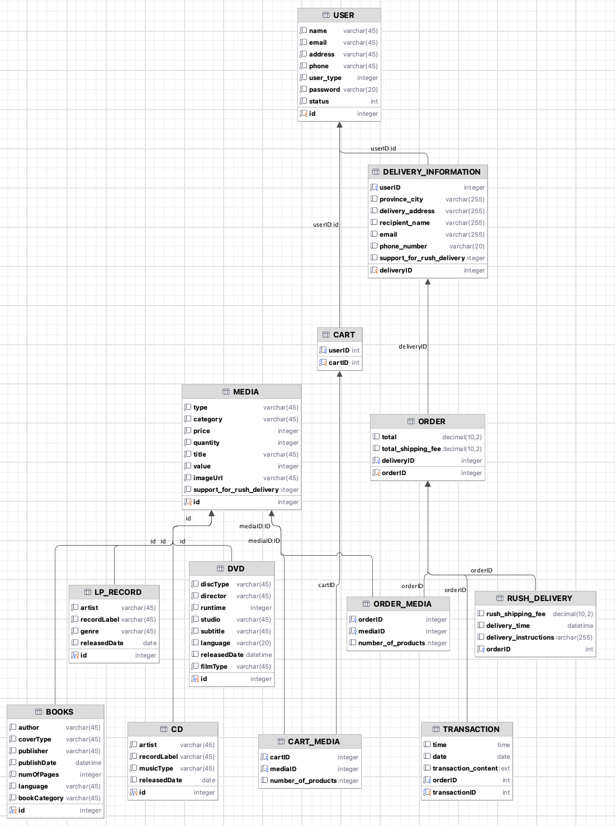

#### Database Detail Design

Table 1. USER

|  |  |  |  |  |  |  |  |
| --- | --- | --- | --- | --- | --- | --- | --- |
| *#* | *PK* | *FK* | *Column name* | *Data type* | *Default value* | *Mandatory* | *Description* |
| 1 | x |  | id | integer |  | X | Unique identifier for each user |
| 2 |  |  | name | varchar(45) |  | X | User's name |
| 3 |  |  | email | varchar(45) |  | X | User's email address |
| 4 |  |  | address | varchar(45) |  | X | User's physical address |
| 5 |  |  | phone | varchar(45) |  | X | User's phone number |
| 6 |  |  | user_type | integer |  | X | Type of user (e.g., 0 -customer, 1- seller, 2 - admin) |
| 7 |  |  | password | varchar(20) |  | X | User's password for authentication |
| 8 |  |  | status | integer |  | X | User's current status (e.g., active - 1, blocked - 0) |

Table 2. DELIVERY_INFORMATION

|  |  |  |  |  |  |  |  |
| --- | --- | --- | --- | --- | --- | --- | --- |
| *#* | *PK* | *FK* | *Column name* | *Data type* | *Default value* | *Mandatory* | *Description* |
| 1 |  | x | userID | integer |  | X | FK to user(ID) - User associated with the delivery |
| 2 | x |  | deliveryID | integer |  | X | Identifier for each delivery information |
| 3 |  |  | province_city | varchar(255) |  |  | Province and city for delivery |
| 4 |  |  | delivery_address | varchar(255) |  |  | Full address for delivery |
| 5 |  |  | recipient_name | varchar(255) |  |  | Name of the person receiving the delivery |
| 6 |  |  | email | varchar(255) |  |  | Email of the recipient |
| 7 |  |  | phone_number | varchar(20) |  |  | Phone number of the recipient |
| 8 |  |  | support_for_rush_delivery | integer |  |  | Indicates if rush delivery is supported (supported – 1, not supported – 0) |

Table 3. MEDIA

|  |  |  |  |  |  |  |  |
| --- | --- | --- | --- | --- | --- | --- | --- |
| *#* | *PK* | *FK* | *Column name* | *Data type* | *Default value* | *Mandatory* | *Description* |
| 1 | x |  | id | integer |  | X | Unique identifier for each media item |
| 2 |  |  | type | varchar(45) |  | X | Type of media (e.g., DVD, CD, Book) |
| 3 |  |  | category | varchar(45) |  | X | Category or genre of the media |
| 4 |  |  | price | integer |  | X | Current price of the media item |
| 5 |  |  | quantity | integer |  | X | Available quantity of the media item |
| 6 |  |  | title | varchar(45) |  | X | Title of the media item |
| 7 |  |  | value | integer |  | X | Value or cost of the media item |
| 8 |  |  | imageUrl | varchar(45) |  | x | URL for the media item's image |
| 9 |  |  | support_for_rush_delivery | integer |  | x | Indicates if rush delivery is supported (supported – 1, not supported – 0) |

Table 4. CART

|  |  |  |  |  |  |  |  |
| --- | --- | --- | --- | --- | --- | --- | --- |
| *#* | *PK* | *FK* | *Column name* | *Data type* | *Default value* | *Mandatory* | *Description* |
| 1 |  | x | userID | integer |  | X | FK to user(ID) - User associated with the cart |
| 2 | x |  | cartID | integer |  | X | Unique identifier for each cart |

Table 5. ORDER

|  |  |  |  |  |  |  |  |
| --- | --- | --- | --- | --- | --- | --- | --- |
| *#* | *PK* | *FK* | *Column name* | *Data type* | *Default value* | *Mandatory* | *Description* |
| 1 |  | x | deliveryID | integer |  | X | FK to DELIVERY_INFORMATION  (deliveryID) - Delivery information associated with the order |
| 2 | x |  | orderID | integer |  | X | Unique identifier for each order |
| 3 |  |  | total | decimal(10,2) |  |  | Total amount of the order |
| 4 |  |  | total_shipping_fee | decimal(10,2) |  |  | Total shipping fee for the order |

Table 6. DVD

|  |  |  |  |  |  |  |  |
| --- | --- | --- | --- | --- | --- | --- | --- |
| *#* | *PK* | *FK* | *Column name* | *Data type* | *Default value* | *Mandatory* | *Description* |
| 1 | x | x | id | integer |  | X | FK to MEDIA(id) - Media item associated with the DVD |
| 2 |  |  | discType | varchar(45) |  | X | Type of DVD disc (e.g., DVD-R, DVD+R) |
| 3 |  |  | director | varchar(45) |  | X | Director of the DVD content |
| 4 |  |  | runtime | integer |  | X | Runtime duration of the DVD in minutes |
| 5 |  |  | studio | varchar(45) |  | X | Studio that produced the DVD |
| 6 |  |  | subtitle | varchar(45) |  | X | Subtitle languages available on the DVD |
| 7 |  |  | language | varchar(20) |  | X | Audio languages available on the DVD |
| 8 |  |  | releasedDate | datetime |  |  | Date when the DVD was released |
| 9 |  |  | filmType | varchar(45) |  | X | Type of film (e.g., movie, documentary) |

Table 7. LP_RECORD

|  |  |  |  |  |  |  |  |
| --- | --- | --- | --- | --- | --- | --- | --- |
| *#* | *PK* | *FK* | *Column name* | *Data type* | *Default value* | *Mandatory* | *Description* |
| 1 | x | x | id | integer |  | X | FK to MEDIA(id) - Media item associated with the LP_RECORD |
| 2 |  |  | artist | varchar(45) |  | X | Artist or band of the LP record |
| 3 |  |  | recordLabel | varchar(45) |  | X | Record label that released the LP |
| 4 |  |  | genre | varchar(45) |  | X | Genre or style of music on the LP |
| 5 |  |  | releaseDate | date |  |  | Date when the LP was released |

Table 8. CD

|  |  |  |  |  |  |  |  |
| --- | --- | --- | --- | --- | --- | --- | --- |
| *#* | *PK* | *FK* | *Column name* | *Data type* | *Default value* | *Mandatory* | *Description* |
| 1 | x | x | id | integer |  | X | FK to MEDIA(id) - Media item associated with the CD |
| 2 |  |  | artist | varchar(45) |  | X | Artist or band of the CD |
| 3 |  |  | recordLabel | varchar(45) |  | X | Record label that released the CD |
| 4 |  |  | genre | varchar(45) |  | X | Genre or style of music on the CD |
| 5 |  |  | releaseDate | date |  |  | Date when the CD was released |

Table 9. BOOKS

|  |  |  |  |  |  |  |  |
| --- | --- | --- | --- | --- | --- | --- | --- |
| *#* | *PK* | *FK* | *Column name* | *Data type* | *Default value* | *Mandatory* | *Description* |
| 1 | x | x | id | integer |  | X | FK to MEDIA(id) - Media item associated with the BOOK |
| 2 |  |  | author | varchar(45) |  | X | Author of the book |
| 3 |  |  | coverType | varchar(45) |  | X | Type of book cover (e.g., hardcover, paperback) |
| 4 |  |  | publisher | varchar(45) |  | X | Publisher of the book |
| 5 |  |  | publishDate | datetime |  | X | Date when the book was published |
| 6 |  |  | numberPages | integer |  | X | Number of pages in the book |
| 7 |  |  | language | varchar(45) |  | X | Language in which the book is written |
| 8 |  |  | bookCategory | varchar(45) |  | X | Category or genre of the book |

Table 10. ORDER_MEDIA

|  |  |  |  |  |  |  |  |
| --- | --- | --- | --- | --- | --- | --- | --- |
| *#* | *PK* | *FK* | *Column name* | *Data type* | *Default value* | *Mandatory* | *Description* |
| 1 | x |  | orderID | integer |  |  | FK to ORDER(orderID) - Order associated with the media items |
| 2 |  | x | mediaID | integer |  |  | FK to MEDIA(id) - Media item included in the order |
| 3 |  |  | number_of_products | integer |  |  | Number of units of the media item in the order |

Table 11. CART_MEDIA

|  |  |  |  |  |  |  |  |
| --- | --- | --- | --- | --- | --- | --- | --- |
| *#* | *PK* | *FK* | *Column name* | *Data type* | *Default value* | *Mandatory* | *Description* |
| 1 | x |  | cartID | integer |  | X | FK to CART(cartID) - Cart associated with the media items |
| 2 |  | x | mediaID | integer |  | X | FK to MEDIA(id) - Media item included in the cart |
| 3 |  |  | number_of_products | integer |  |  | Number of units of the media item in the cart |

Table 12. RUSH_DELIVERY

|  |  |  |  |  |  |  |  |
| --- | --- | --- | --- | --- | --- | --- | --- |
| *#* | *PK* | *FK* | *Column name* | *Data type* | *Default value* | *Mandatory* | *Description* |
| 1 |  |  | rush_shipping_fee | decimal(10,2) |  |  | Additional fee for rush shipping |
| 2 |  |  | delivery_time | datetime |  |  | Estimated delivery time for rush shipping |
| 3 |  |  | delivery_instructions | varchar(255) |  |  | Special instructions for rush delivery |
| 4 |  | x | orderID | integer |  | x | FK to ORDER(orderID) - Order associated with the rush delivery |

Table 13. TRANSACTION

|  |  |  |  |  |  |  |  |
| --- | --- | --- | --- | --- | --- | --- | --- |
| *#* | *PK* | *FK* | *Column name* | *Data type* | *Default value* | *Mandatory* | *Description* |
| 1 |  | x | orderID | integer |  | X | FK to ORDER(orderID) - Order associated with the transaction |
| 2 | x |  | transactionID | integer |  | X | Unique identifier for each transaction |
| 3 |  |  | transaction_content | text |  |  | Details or content of the transaction |
| 4 |  |  | time | time |  |  | Time of the transaction |
| 5 |  |  | date | date |  |  | Date of the transaction |

The database script

*-- Table: User*CREATE TABLE "USER"(  
 "id" INTEGER PRIMARY KEY AUTOINCREMENT NOT NULL,  
 "name" VARCHAR(45) NOT NULL,  
 "email" VARCHAR(45) NOT NULL,  
 "address" VARCHAR(45) NOT NULL,  
 "phone" VARCHAR(45) NOT NULL,  
 "user_type" INTEGER NOT NULL,  
 "password" VARCHAR(20) NOT NULL,  
 "status" INT NOT NULL  
);  
*-- Media-related tables*CREATE TABLE "MEDIA"(  
 "id" INTEGER PRIMARY KEY AUTOINCREMENT NOT NULL,  
 "type" VARCHAR(45) NOT NULL,  
 "category" VARCHAR(45) NOT NULL,  
 "price" INTEGER NOT NULL,  
 "quantity" INTEGER NOT NULL,  
 "title" VARCHAR(45) NOT NULL,  
 "value" INTEGER NOT NULL,  
 "imageUrl" VARCHAR(45) NOT NULL,  
 "support_for_rush_delivery" INTEGER NOT NULL  
);  
  
CREATE TABLE "CD"(  
 "id" INTEGER PRIMARY KEY NOT NULL,  
 "artist" VARCHAR(45) NOT NULL,  
 "recordLabel" VARCHAR(45) NOT NULL,  
 "musicType" VARCHAR(45) NOT NULL,  
 "releasedDate" DATE,  
 CONSTRAINT "fk_cd_media" FOREIGN KEY("id") REFERENCES "MEDIA"("id")  
);  
  
CREATE TABLE "BOOKS"(  
 "id" INTEGER PRIMARY KEY NOT NULL,  
 "author" VARCHAR(45) NOT NULL,  
 "coverType" VARCHAR(45) NOT NULL,  
 "publisher" VARCHAR(45) NOT NULL,  
 "publishDate" DATETIME NOT NULL,  
 "numOfPages" INTEGER NOT NULL,  
 "language" VARCHAR(45) NOT NULL,  
 "bookCategory" VARCHAR(45) NOT NULL,  
 CONSTRAINT "fk_book_media" FOREIGN KEY("id") REFERENCES "MEDIA"("id")  
);  
  
CREATE TABLE "DVD"(  
 "id" INTEGER PRIMARY KEY NOT NULL,  
 "discType" VARCHAR(45) NOT NULL,  
 "director" VARCHAR(45) NOT NULL,  
 "runtime" INTEGER NOT NULL,  
 "studio" VARCHAR(45) NOT NULL,  
 "subtitle" VARCHAR(45) NOT NULL,  
 "language" VARCHAR(20),  
 "releasedDate" DATETIME,  
 "filmType" VARCHAR(45) NOT NULL,  
 CONSTRAINT "fk_dvd_media" FOREIGN KEY("id") REFERENCES "MEDIA"("id")  
);  
CREATE TABLE "LP_RECORD"(  
 "id" INTEGER PRIMARY KEY NOT NULL,  
 "artist" VARCHAR(45) NOT NULL,  
 "recordLabel" VARCHAR(45) NOT NULL,  
 "genre" VARCHAR(45) NOT NULL,  
 "releasedDate" DATE,  
 CONSTRAINT "fk_lp_media" FOREIGN KEY("id") REFERENCES "MEDIA"("id")  
);  
  
*-- Table: Cart*CREATE TABLE CART (  
 cartID INT NOT NULL PRIMARY KEY,  
 userID INT NOT NULL,  
 CONSTRAINT "fk_cart_user" FOREIGN KEY("userID") REFERENCES "USER"("id")  
);  
  
*-- Table: Cart_Media*CREATE TABLE "CART_MEDIA" (  
 cartID INTEGER NOT NULL,  
 mediaID INTEGER NOT NULL,  
 number_of_products INTEGER,  
 CONSTRAINT "fk_cart_cartmedia" FOREIGN KEY ("cartID") REFERENCES "CART"("cartID"),  
 CONSTRAINT "fk_media_cartmedia" FOREIGN KEY ("mediaID") REFERENCES "MEDIA"("ID")  
);  
  
  
*-- Table: Delivery_information*CREATE TABLE "DELIVERY_INFORMATION" (  
 deliveryID INTEGER NOT NULL PRIMARY KEY,  
 userID INTEGER NOT NULL,  
 province_city VARCHAR(255),  
 delivery_address VARCHAR(255),  
 recipient_name VARCHAR(255),  
 email VARCHAR(255),  
 phone_number VARCHAR(20),  
 support_for_rush_delivery INTEGER,  
 CONSTRAINT "fk_delivery_user" FOREIGN KEY ("userID") REFERENCES USER("id")  
);  
  
*-- Table: Order*CREATE TABLE "ORDER" (  
 orderID INTEGER NOT NULL PRIMARY KEY,  
 total DECIMAL(10, 2),  
 total_shipping_fee DECIMAL(10,2),  
 deliveryID INTEGER NOT NULL,  
 FOREIGN KEY (deliveryID) REFERENCES Delivery_information(deliveryID)  
);  
  
*-- Table: Order_Media*CREATE TABLE "ORDER_MEDIA" (  
 orderID INTEGER NOT NULL,  
 mediaID INTEGER NOT NULL,  
 number_of_products INTEGER,  
 CONSTRAINT "fk_order_cartmedia" FOREIGN KEY ("orderID") REFERENCES "ORDER"("orderID"),  
 CONSTRAINT "fk_media_cartmedia" FOREIGN KEY ("mediaID") REFERENCES "MEDIA"("ID")  
);  
  
*-- Table: Rush_delivery*CREATE TABLE RUSH_DELIVERY (  
 rush_shipping_fee DECIMAL(10, 2),  
 delivery_time DATETIME,  
 delivery_instructions VARCHAR(255),  
 orderID INT NOT NULL,  
 FOREIGN KEY (orderID) REFERENCES "ORDER"(orderID)  
);  
  
*-- Table: Transaction*CREATE TABLE [TRANSACTION] (  
 transactionID INT NOT NULL PRIMARY KEY,  
 time TIME,  
 date DATE,  
 transaction_content TEXT,  
 orderID INT NOT NULL,  
 CONSTRAINT "fk_order_transaction" FOREIGN KEY ("orderID") REFERENCES "ORDER"(orderID)  
);

## Non-Database Management System Files

*<Provide the detailed description of all non-DBMS files if any and include a narrative description of the usage of each file that identifies if the file is used for input, output, or both, and if the file is a temporary file. Also provide an indication of which modules read and write the file and include file structures (refer to the data dictionary). As appropriate, the file structure information should include the following:*

*• Record structures, record keys or indexes, and data elements referenced within the records*

*• Record length (fixed or maximum variable length) and blocking factors*

*• Access method (e.g., index sequential, virtual sequential, random access, etc.)*

*• Estimate of the file size or volume of data within the file, including overhead resulting from file access methods*

*• Definition of the update frequency of the file (If the file is part of an online transaction-based system, provide the estimated number of transactions per unit of time, and the statistical mean, mode, and distribution of those transactions.)*

*• Backup and recovery specifications>*

## Class Design

### General Class Diagram

<General class diagram which shows the whole class diagram of the software. This diagram may have packages, subsystems and classes. Classes in this diagram may not have all attributes and operations>

### Class Diagrams

<Detail class diagram with full attributes and operations>

#### Class Diagram for Package Controller

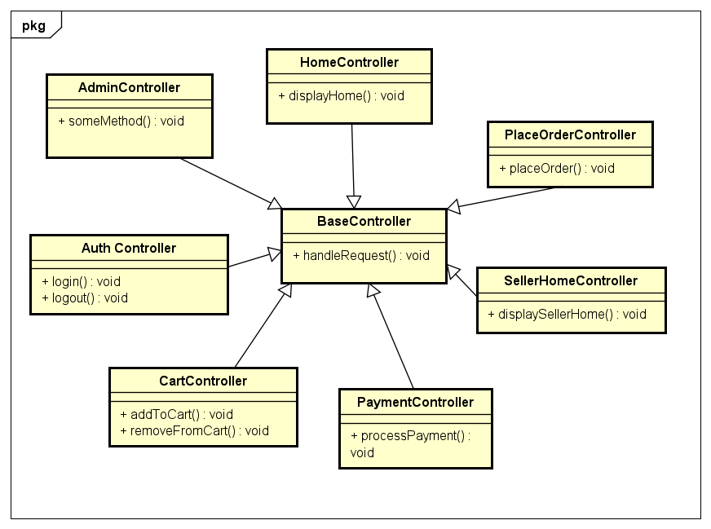

#### Class Diagram for Package DAO

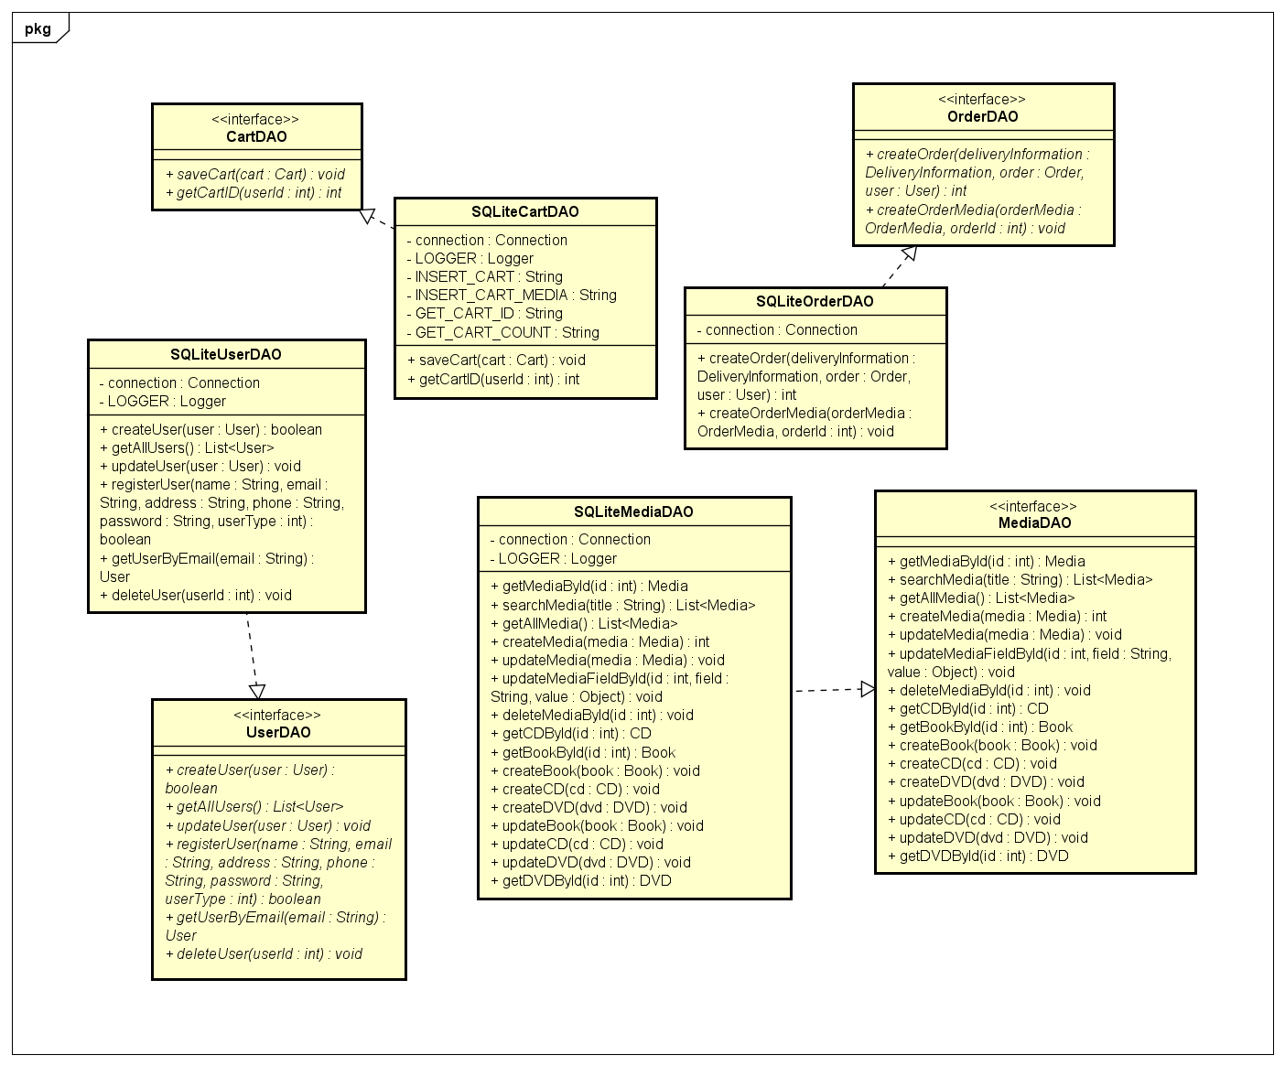

#### Class Diagram for Package db

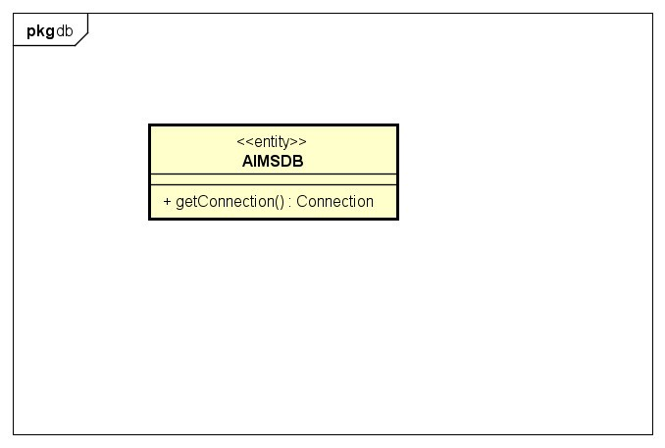

#### Class Diagram for Package Entity

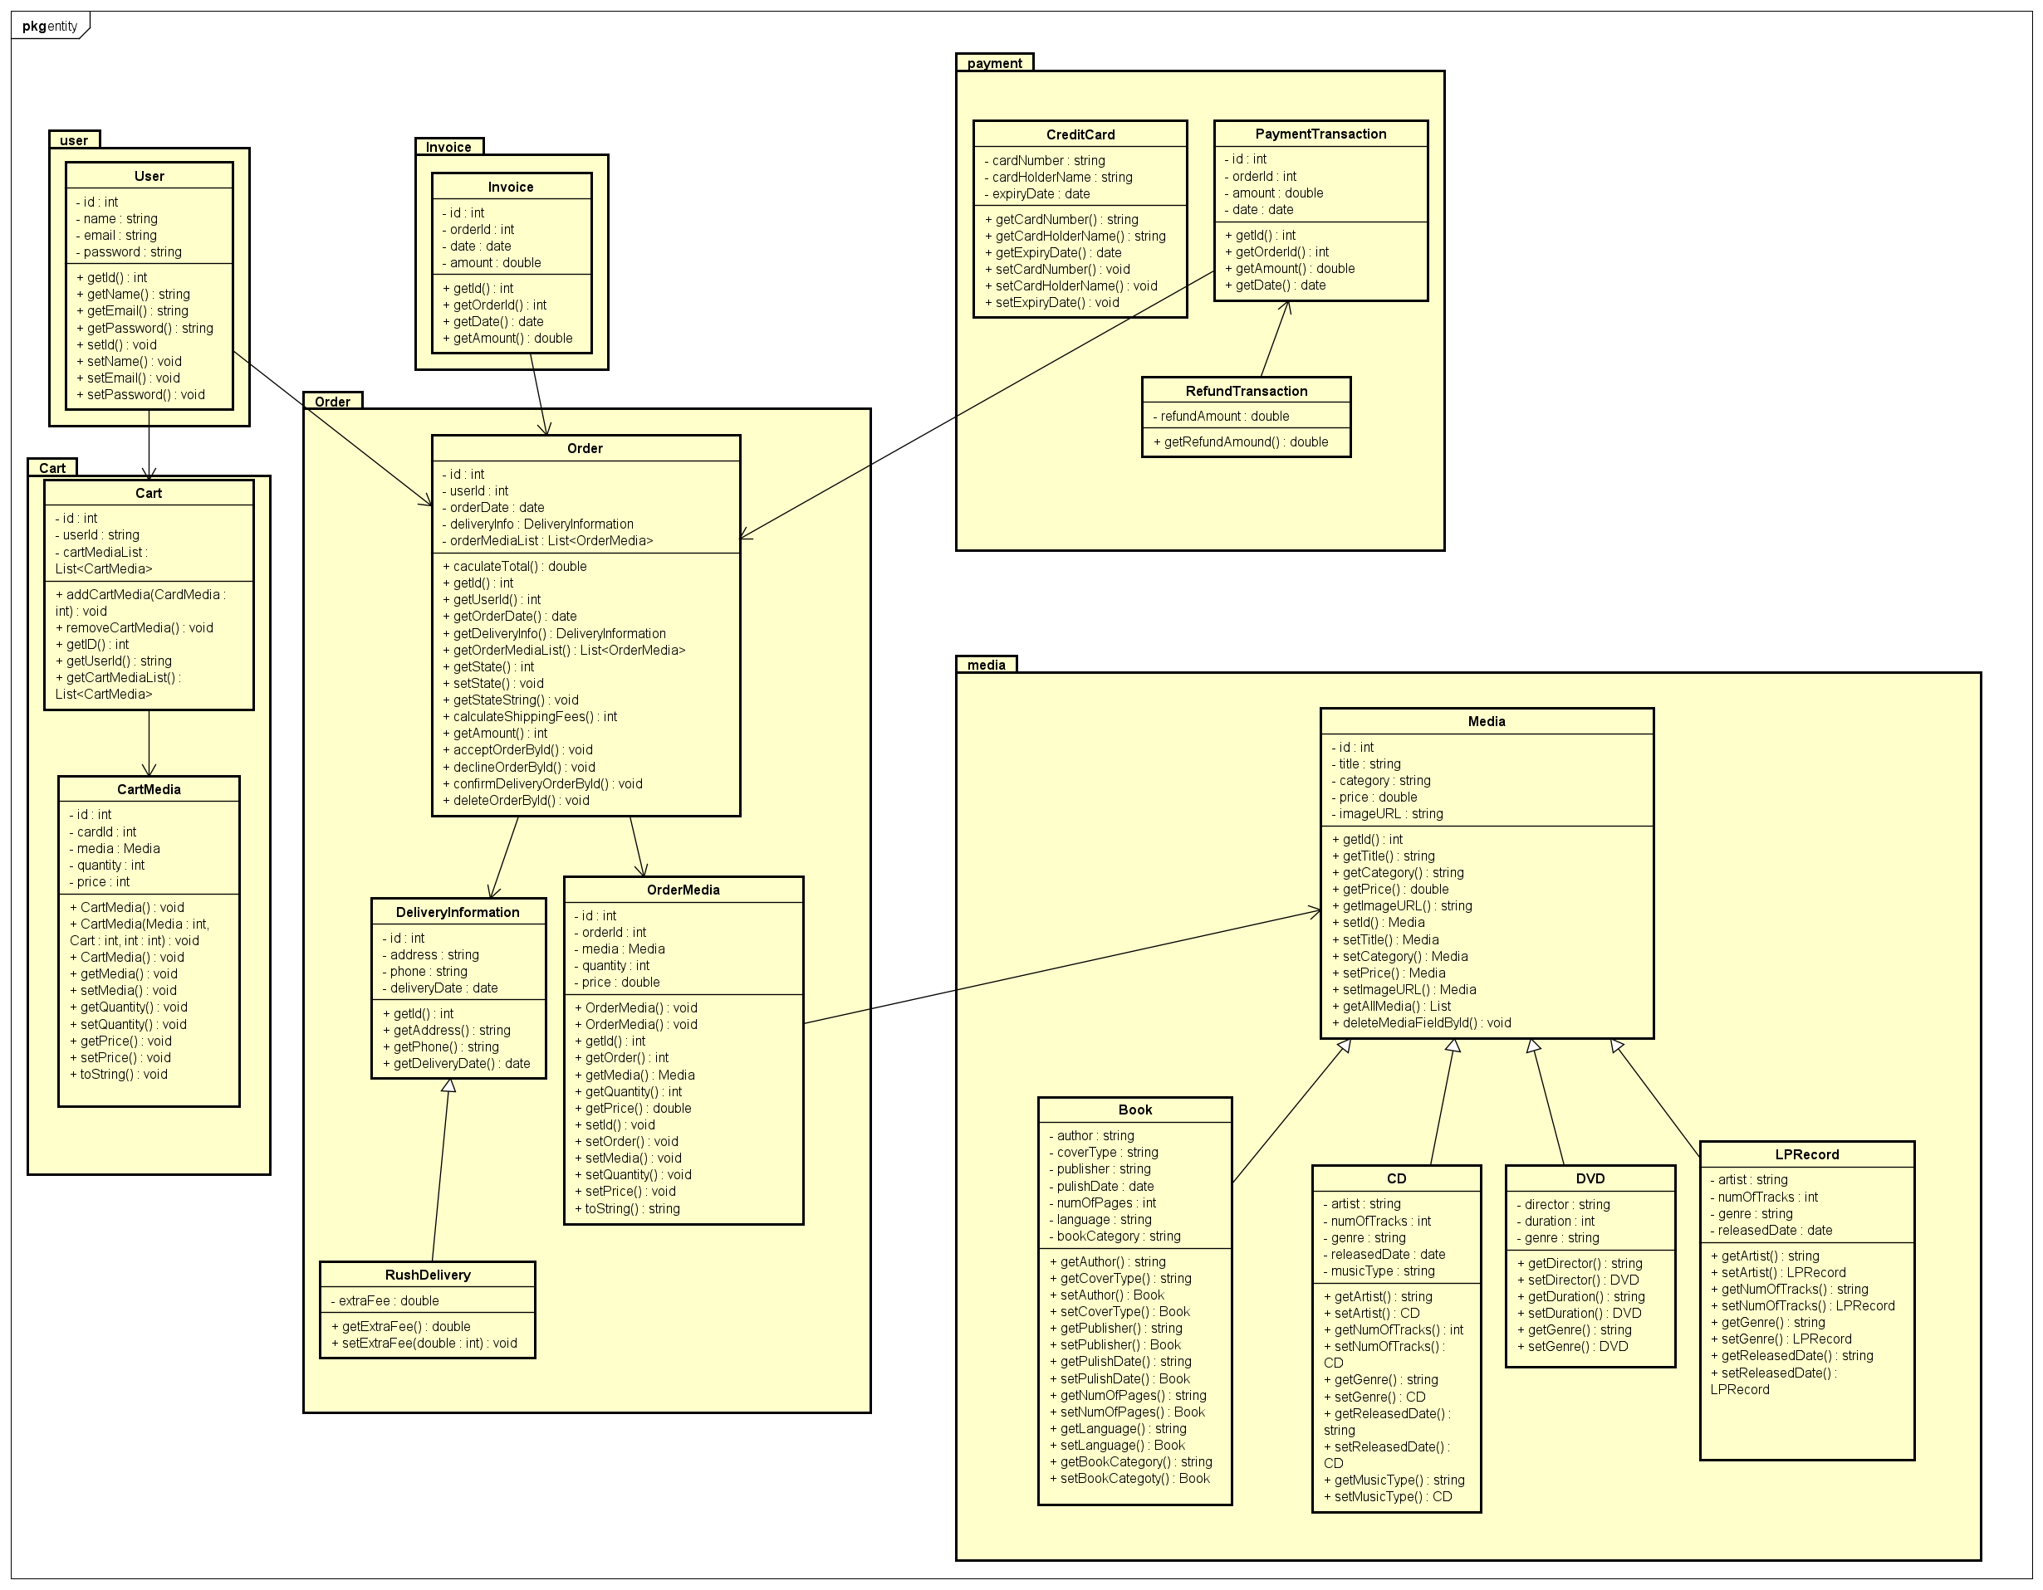

#### Class Diagram for Package Services

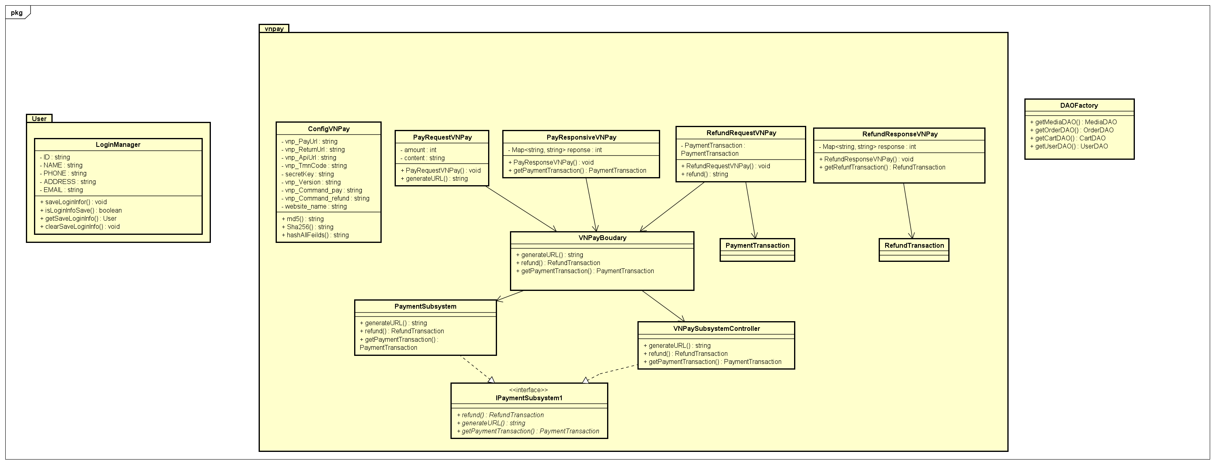

#### Class Diagram for Package Views

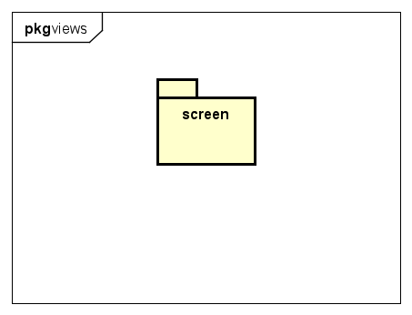

* Package views.screen

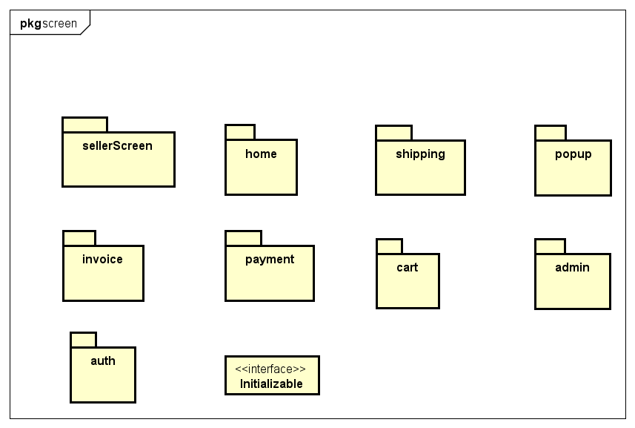

* Package views.admin

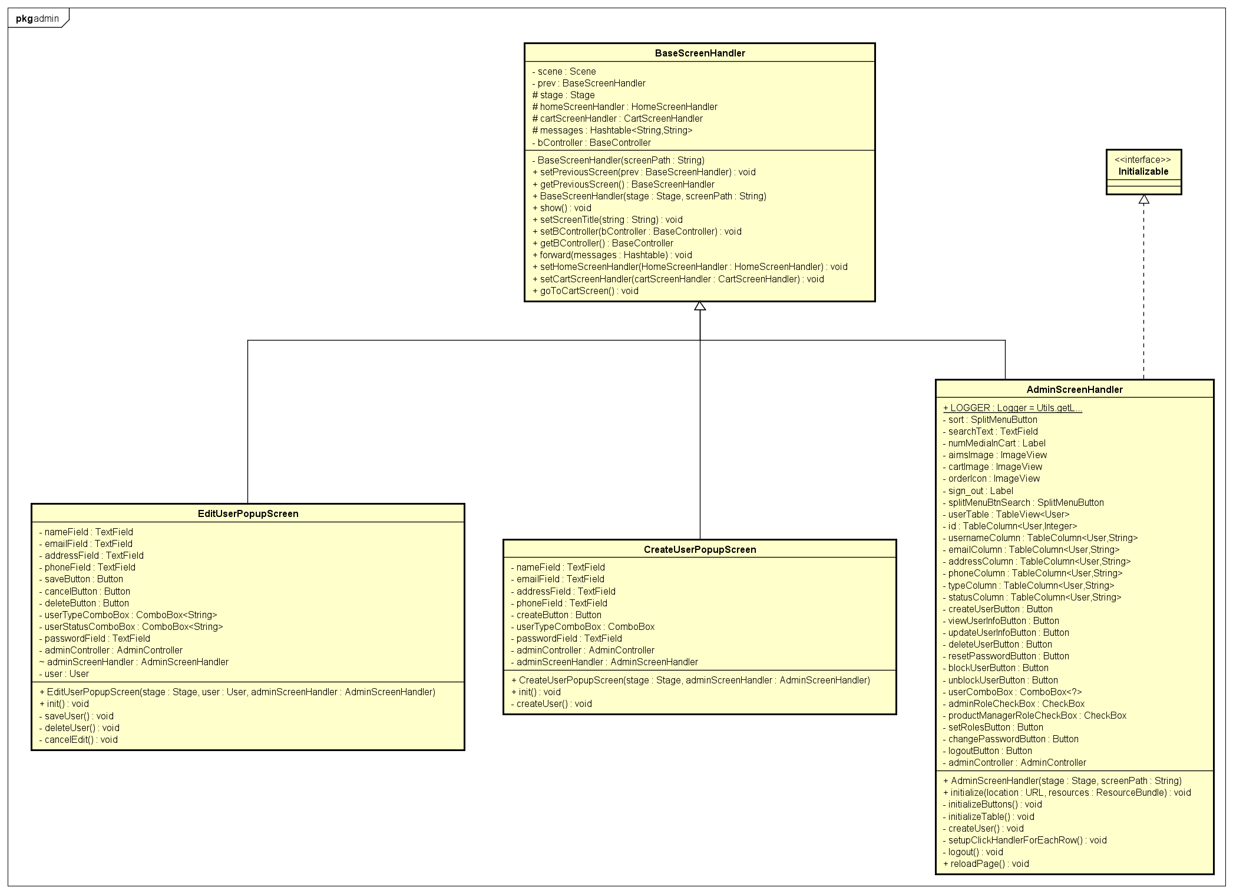

* Package views.auth

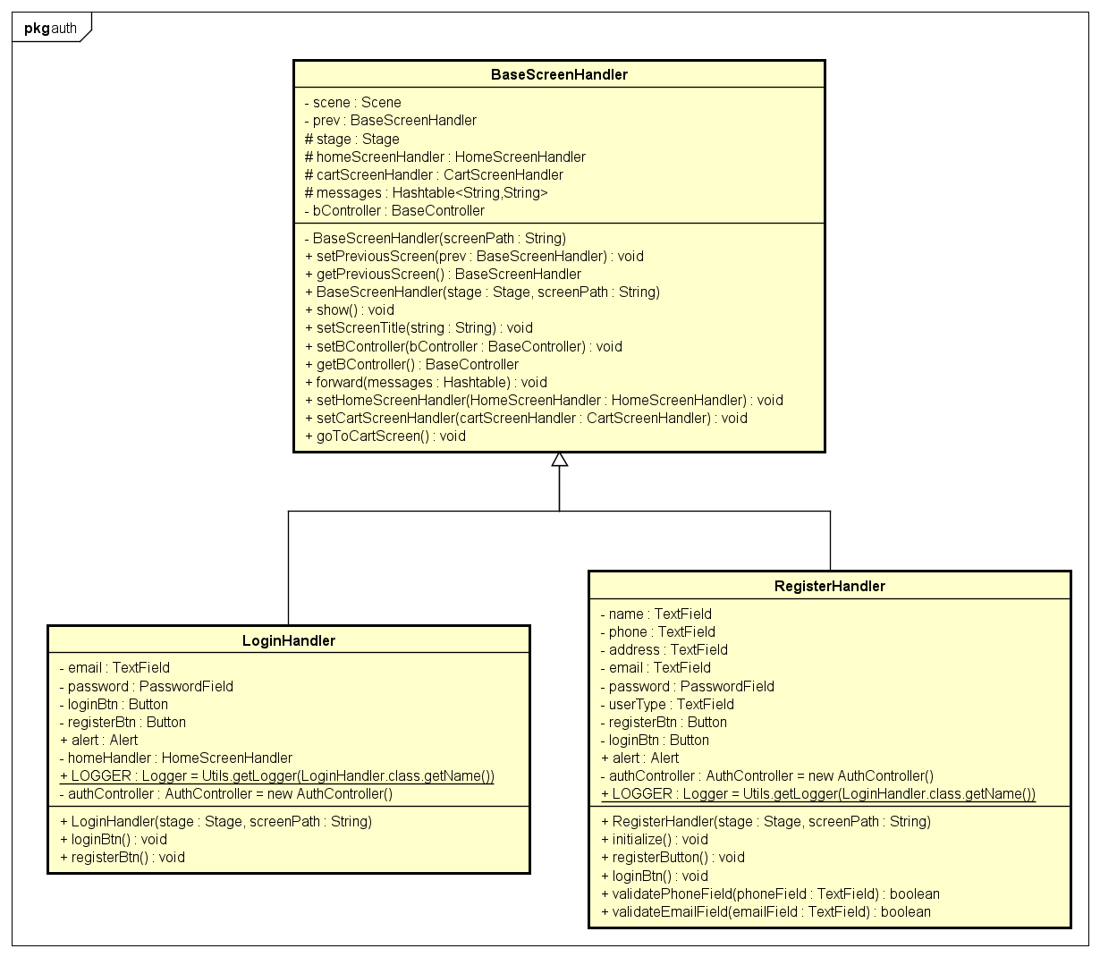

* Package views.cart



* Package views.home

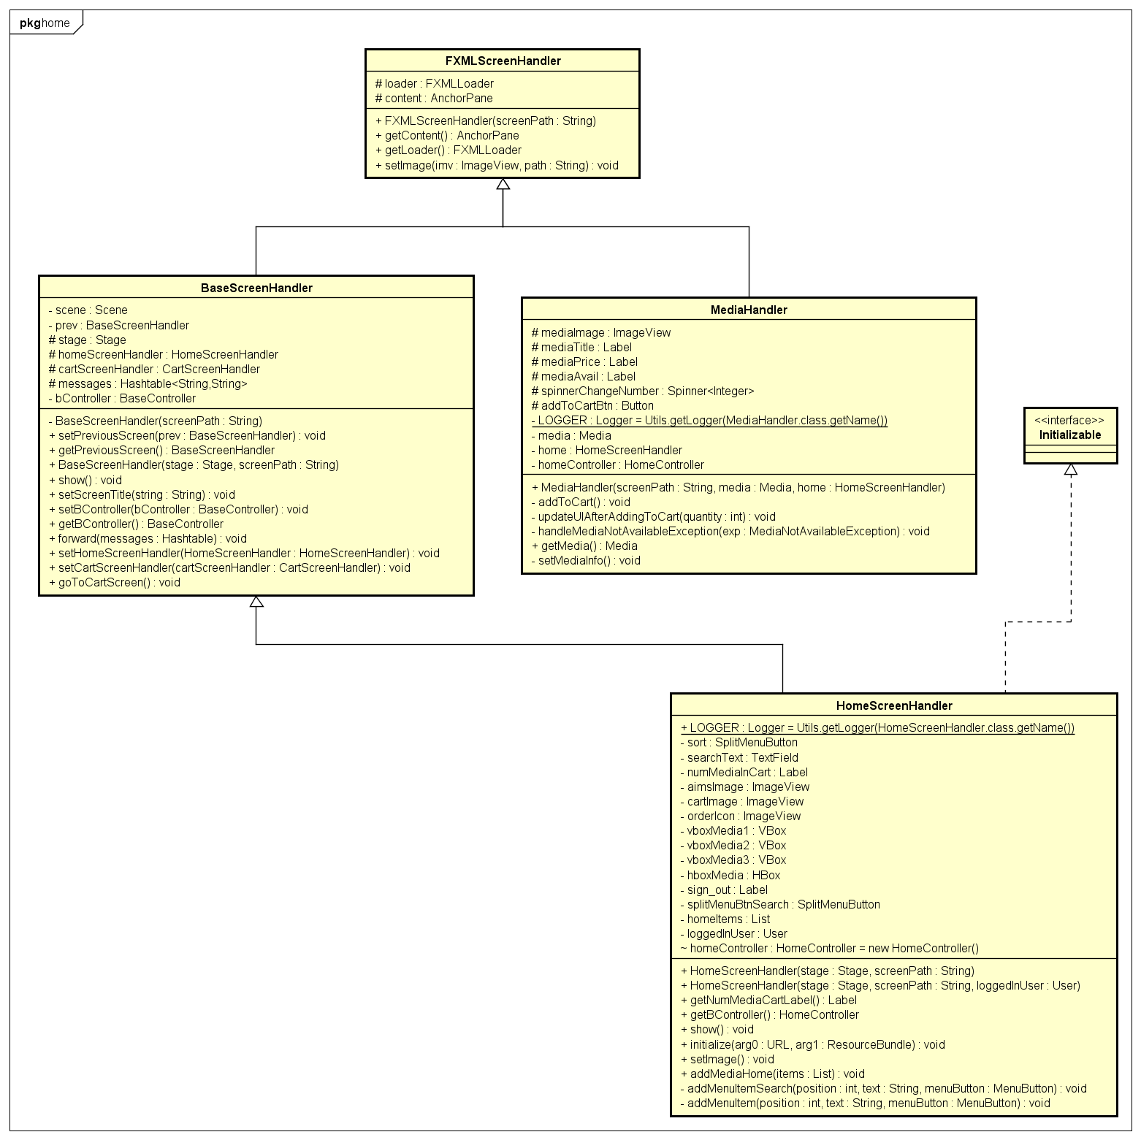

* Package views.invoice

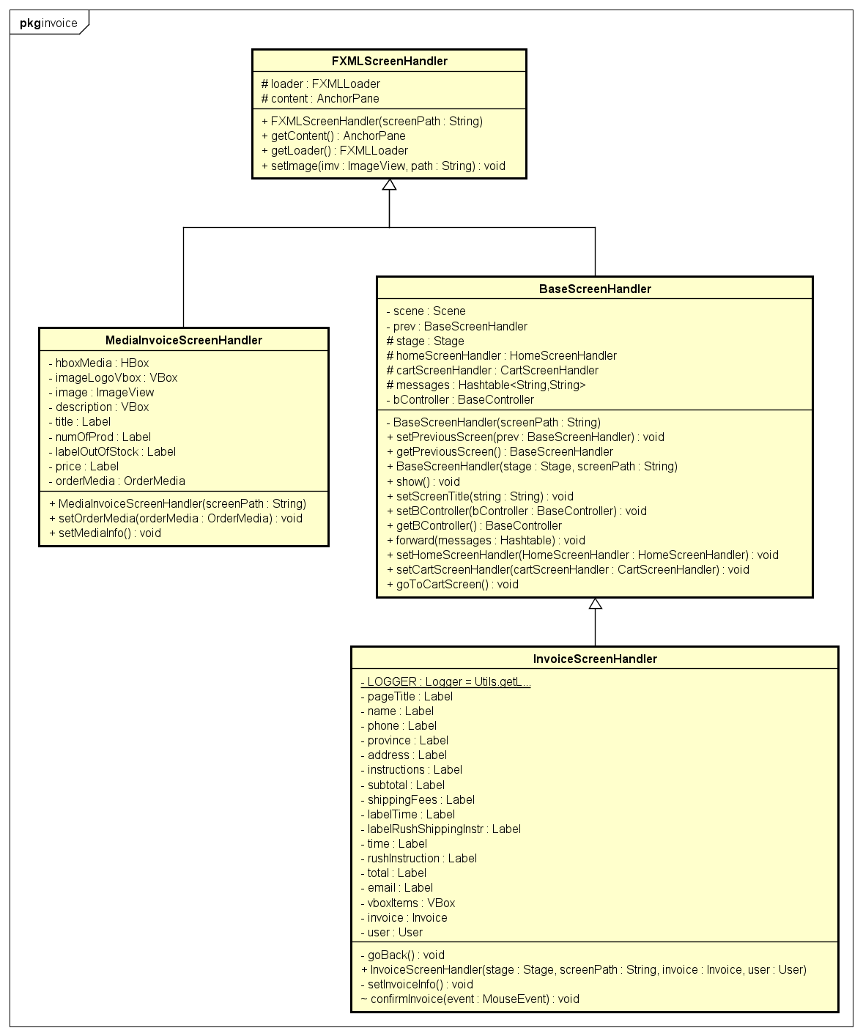

* Package views.payment

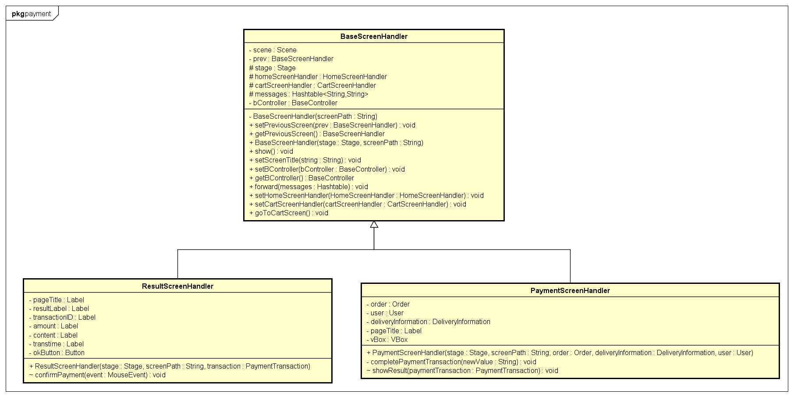

* Package views.popup

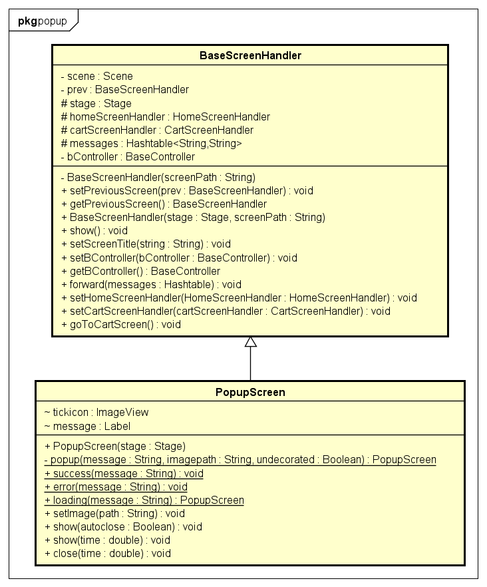

* Package views.sellerScreen

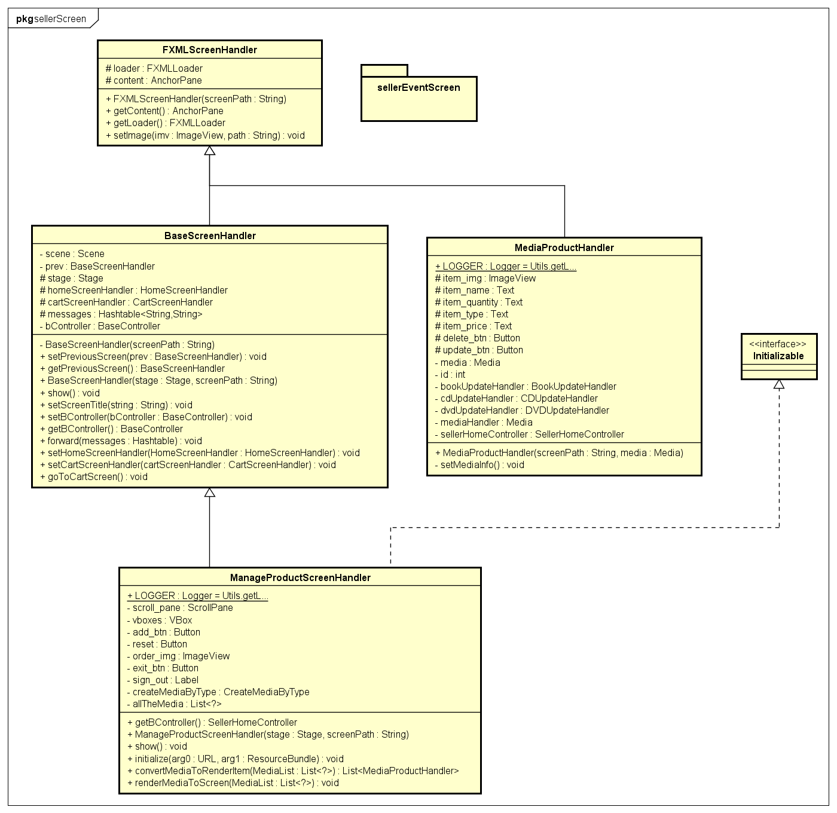

* Package views.sellerScreen.sellerEventScreen

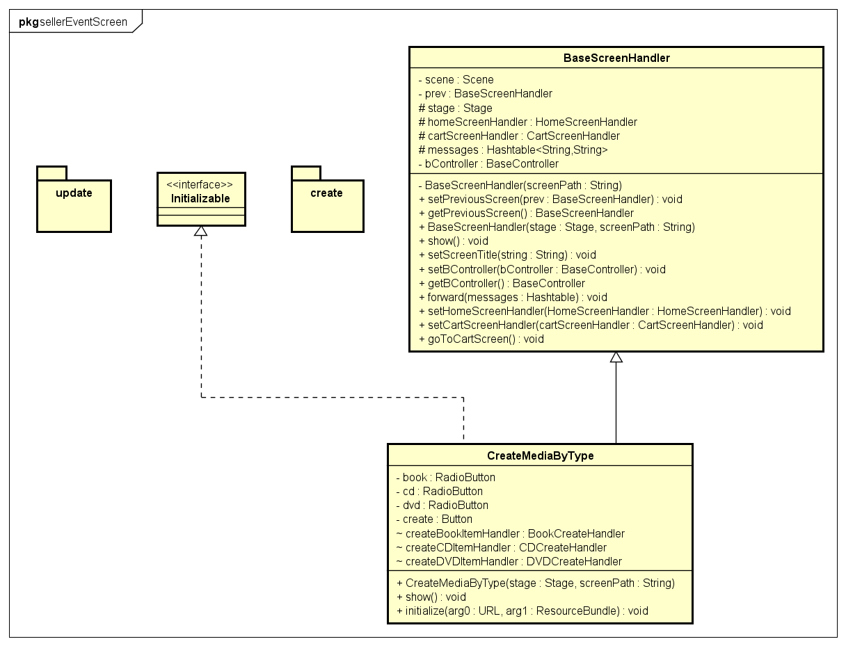

* Package views.sellerScreen.sellerEventScreen.create

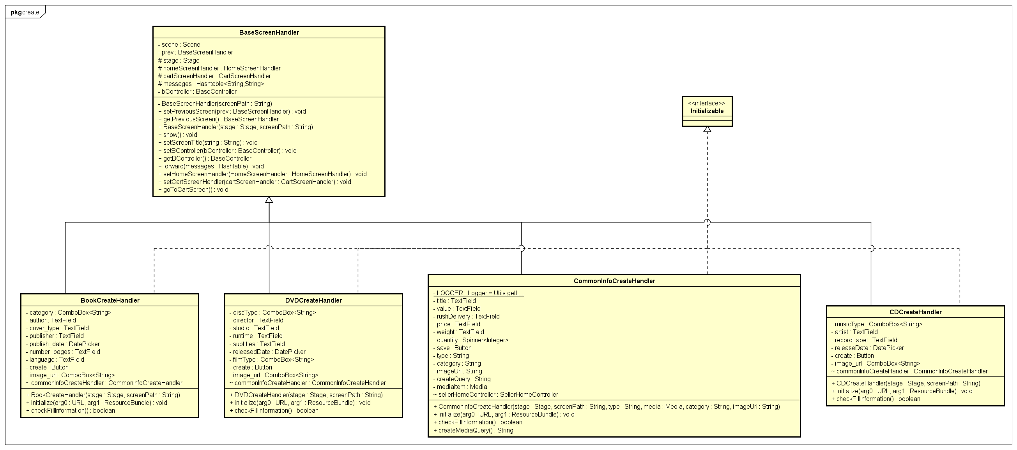

* Package views.sellerScreen.sellerEventScreen.update

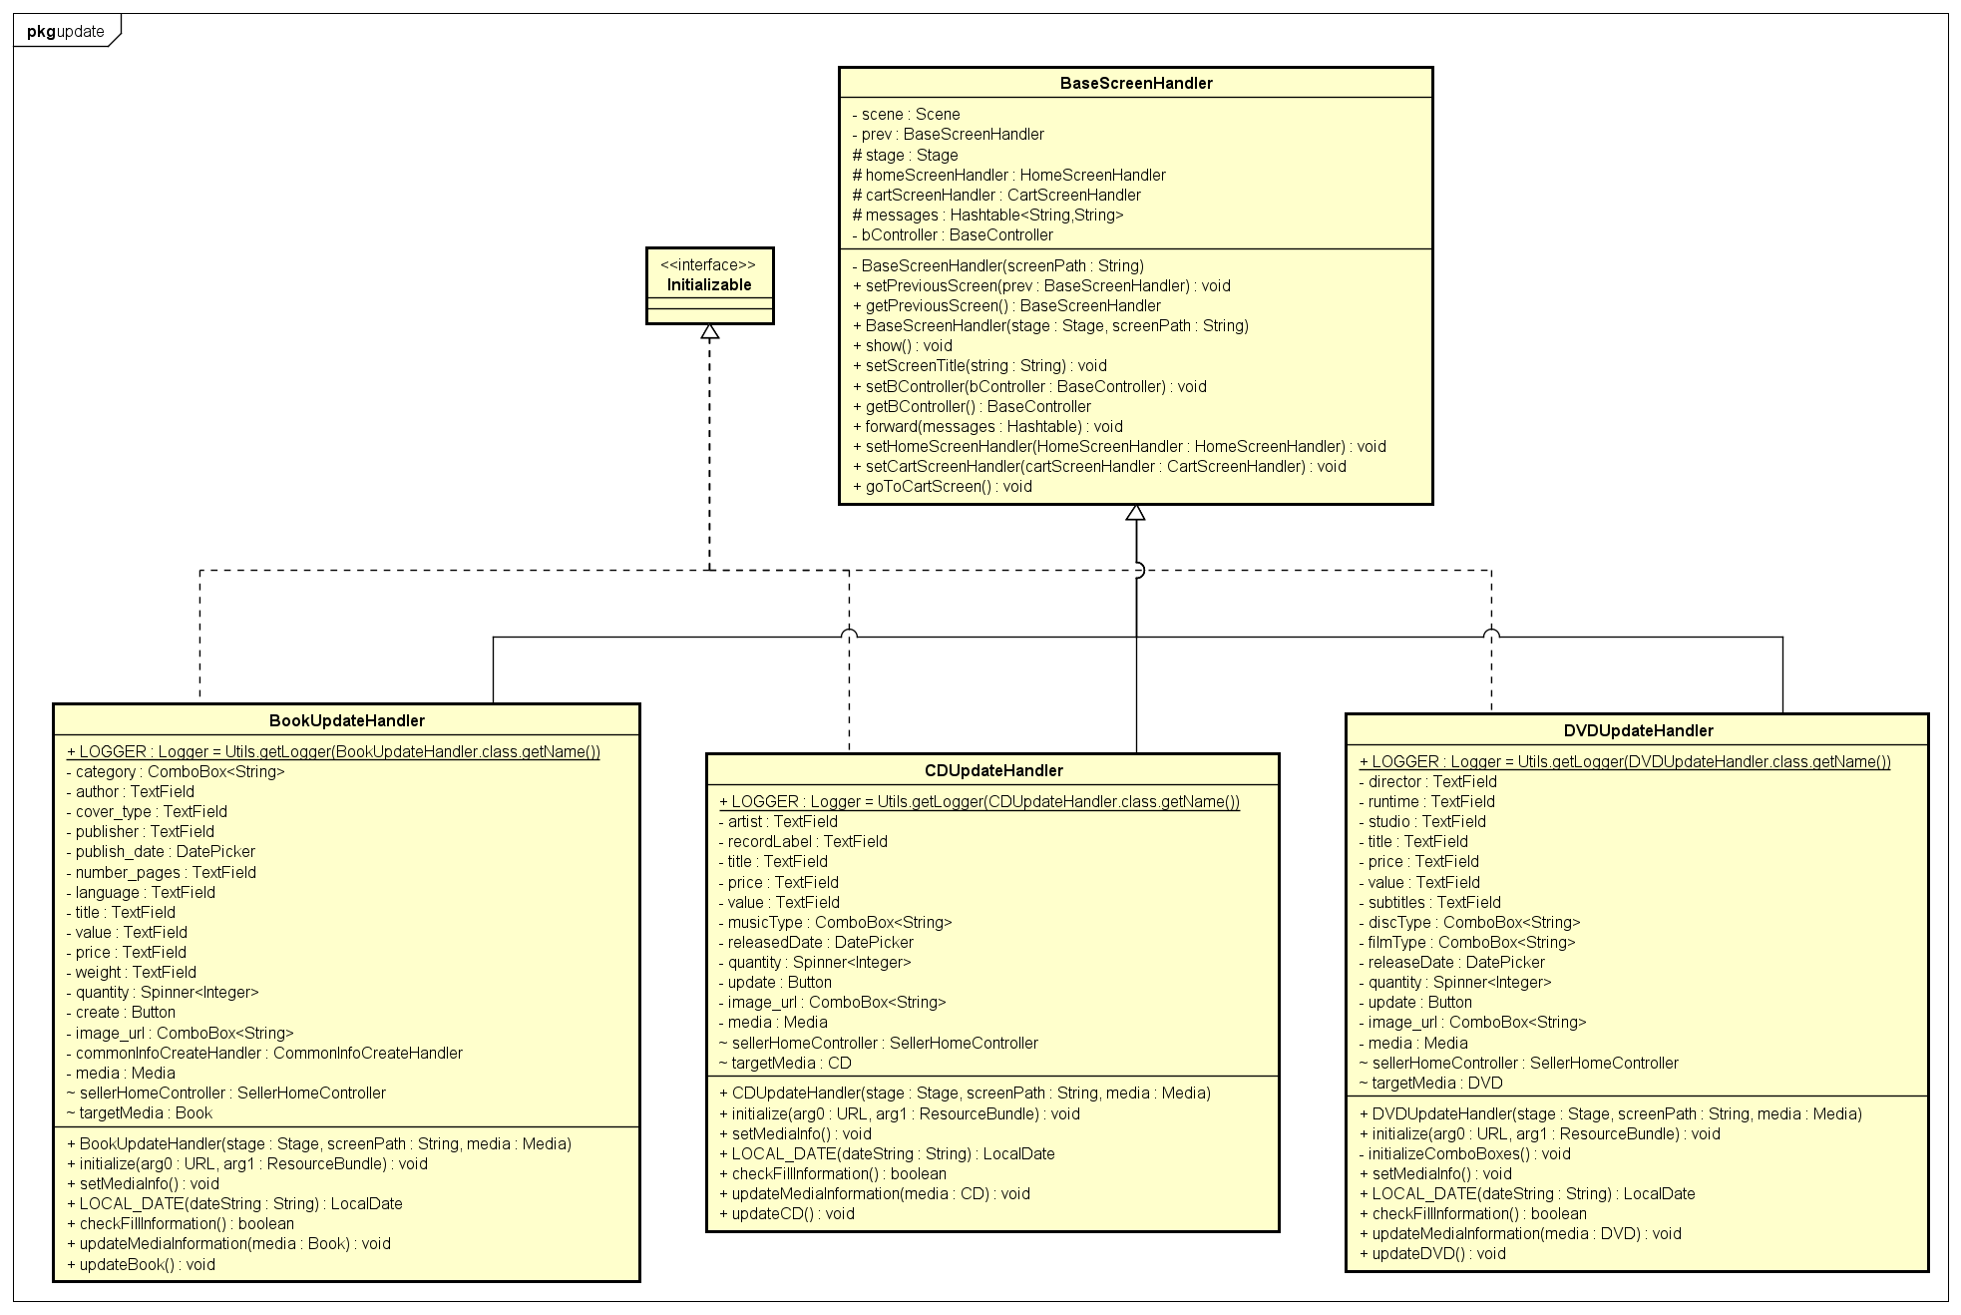

* Package views.shipping

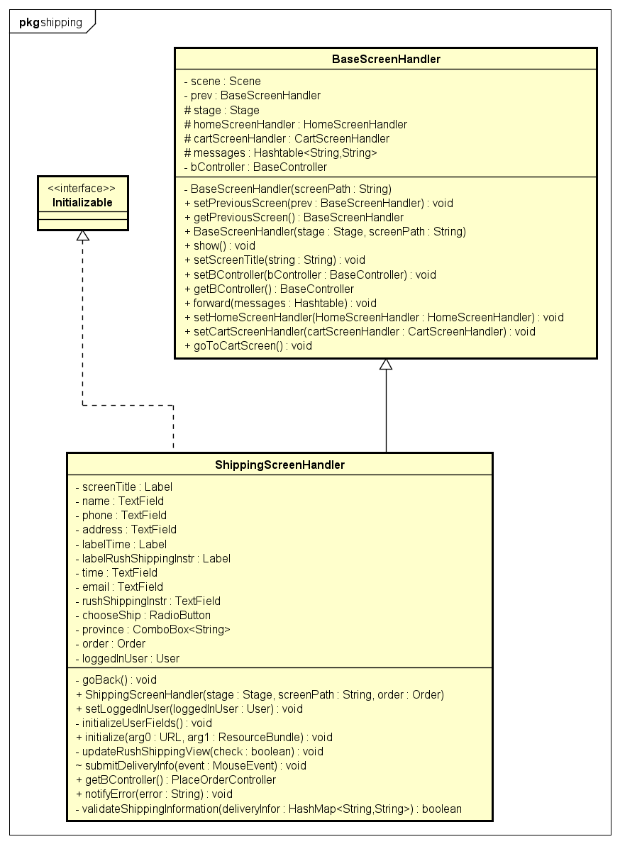

### Class Design

<Detail design for each class>

#### Class “SQLiteOrderDAO”

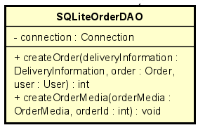

Table 1. Example of attribute design

|  |  |  |  |  |
| --- | --- | --- | --- | --- |
| *#* | *Name* | *Data type* | *Default value* | *Description* |
| 1 | connection | Connection | null | Database connection object |

Table 1. Example of operation design

|  |  |  |  |
| --- | --- | --- | --- |
| *#* | *Name* | *Return type* | *Description (purpose)* |
| 1 | createOrder | int | reates a new order in the database and returns order ID |
| 2 | createOrderMedia | void | Associates media items with the order in the database |

*Parameter*:

- createOrder

* deliveryInformation: DeliveryInformation object, contains delivery details.
* order: Order object, contains order details.
* user: User object, contains user details.

- createOrderMedia

* orderMedia: OrderMedia object, contains media details for the order.
* orderId: int, unique identifier for the order.

*Exception*:

* CreateOrder: SQLException if there is an error while creating the order in the database.
* CreateOrderMedia: SQLException if there is an error while associating media items with the order.

**Method**

How to use parameters / attributes

Flowchart / Sequence diagram if the method has a complex/special algorithm

**State**

State diagram if any

#### Class “SQLiteCartDAO”

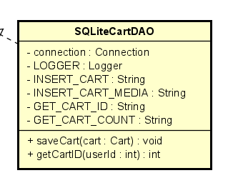

Table 1. Example of attribute design

|  |  |  |  |  |
| --- | --- | --- | --- | --- |
| *#* | *Name* | *Data type* | *Default value* | *Description* |
| 1 | connection | Connection | null | Database connection object |
| 2 | LOGGER | Logger | null | Logger object for logging activities |
| 3 | INSERT_CART | String | null | SQL query string for inserting a cart |
| 4 | INSERT_CART_MEDIA | String | null | SQL query string for inserting cart media |
| 5 | GET_CART_ID | String | null | SQL query string for getting cart ID |
| 6 | GET_CART_COUNT | String | null | SQL query string for getting cart count |

Table 1. Example of operation design

|  |  |  |  |
| --- | --- | --- | --- |
| *#* | *Name* | *Return type* | *Description (purpose)* |
| 1 | getCartID | int | Retrieves the cart ID for a given user |
| 2 | saveCart | void | Saves a cart to the database |

*Parameter*:

- saveCart

* cart: Cart object, contains details of the cart to be saved

- getCartID

* userId: int, unique identifier of the user.

*Exception*:

* saveCart: SQLException if there is an error while saving the cart in the database.
* getCartID: SQLException if there is an error while retrieving the cart ID.

**Method**

How to use parameters / attributes

Flowchart / Sequence diagram if the method has a complex/special algorithm

**State**

State diagram if any

# Design Considerations

This section outlines the key considerations and design choices made for the software system. It addresses the goals, guidelines, architectural strategies, coupling and cohesion, design principles, and design patterns.

## Goals and Guidelines

**Goals:**

* **Performance:** Emphasis on speed and responsiveness over memory use. This is essential to ensure a smooth user experience.
* **Usability:** The software should have an intuitive user interface, closely resembling existing successful products in the same domain to reduce the learning curve for users.
* **Scalability:** The system must be designed to handle increased loads and data volumes without significant performance degradation.
* **Maintainability:** The source code should be easily understandable, modifiable, and extensible to accommodate future changes and enhancements.

**Guidelines:**

* **Coding Conventions:** Adhere to consistent coding styles, including naming conventions, indentation, and comments, to improve readability and maintainability. For example, using CamelCase for class names and methods, and snake_case for variable names.
* **Error Handling:** Implement comprehensive error handling to manage exceptions gracefully and provide meaningful feedback to the user.

**Design Policies and Tactics:**

* **Modular Design:** Break down the system into smaller, manageable modules, each responsible for a specific functionality. This modular approach aids in isolating and resolving issues, as well as facilitating code reuse.
* **Interface Design:** Use interfaces to define contracts for modules, promoting loose coupling and enhancing flexibility in swapping implementations.
* **Version Control:** Employ a robust version control system (e.g., Git) to track changes, manage branches, and facilitate collaboration among developers.

## Architectural Strategies

**Design Decisions and Strategies:**

* **Programming Language:** The system is implemented in Java due to its platform independence, rich set of libraries, and strong community support.
* **Database:** Use SQLite for its simplicity and suitability for local storage in desktop applications when developing application. The choice of SQLite also aligns with the need for a lightweight and self-contained database engine.
* **Component Reuse:** Leverage existing libraries and frameworks for common functionalities such as logging (e.g., Log4j), user interface (e.g., JavaFX), and database access (e.g., JDBC).
* **Extensibility:** Design the system with extension points (e.g., through the use of abstract classes and interfaces, strictly follow 3-tier structure, using suitable design patterns) to allow for future enhancements without significant changes to the existing codebase.
* **User Interface Paradigm:** User interface paradigm is the **Graphical User Interface (GUI)**, implemented using JavaFX. This paradigm is suitable for desktop applications and provides an intuitive and visually appealing way for users to interact with the system.
  + **Event-Driven Input Model:** The system responds to user actions such as button clicks, text input, and menu selections. JavaFX handles these events through event listeners and handlers.
  + **Graphical Output Model:** Information and feedback are presented through various UI components such as labels, tables, and dialogs. This model ensures that users receive clear and immediate feedback on their actions.
* **Error Detection and Recovery:** Implement comprehensive error logging and user-friendly error messages. Ensure the system can recover from non-critical errors without requiring a restart.
* **Memory Management:** Follow best practices for memory management, such as using garbage collection features of Java.
* **Distributed Data Management:** While the initial design does not involve distributed data, the architecture allows for future integration with distributed databases if needed.
* **Concurrency and Synchronization:** Future implementation of Java's concurrency utilities (e.g., ExecutorService) will manage multithreading, ensuring thread safety and avoiding race conditions.
* **Service Layer:** A service layer mediates between the controllers and DAOs, encapsulating business logic and promoting reuse and testability.

## Coupling and Cohesion

**CONTROLLER** .

“Home Controller” class have logical cohesion and stamp coupling. The methods are not strictly performing a single task (functional cohesion), nor do they follow a specific sequence (sequential cohesion). Instead, they are logically grouped under the category of "operations related to the home screen.”, so it is logical cohesion. Also, because it use all of the objects from other classes, it is stamp coupling

Other classes have functional cohesion and stamp coupling. Similarly to Home Controller, other classes pass and receive the whole object. However, they have functional cohesion as the methods are all designated to serve one purpose.

**UTILS**

The classes in the “Utils” package have very low level of cohesion (Coincidental cohesion) and very high level of coupling as it is created as a collection of methods and paths used regularly by other classes, which does not relate to each other. So even though it is at a not-desirable level of cohesion and coupling, it does not need to be changed. Also, there are not many methods in this project, so this package does not need further refactoring.

**ENTITY**

In this package, all classes have high level of cohesion. The classes serve functions of storing information of each object (Communicational cohesion). Also, they are able to retrieve and get information from other classes without modifying the information (Stamp coupling).

**VIEWS.SCREEN**

The handlers in this package has the function of controlling the UI components (button, spinner, title of the screen, etc.) so they have a high cohesion level.

**At previous design**, the classes in this package have stamp coupling. This is not bad but implementation requires internal knowledge of other entity classes. So it is difficult to separate between the back and front end of the system.

*cart.MediaHandler.java* 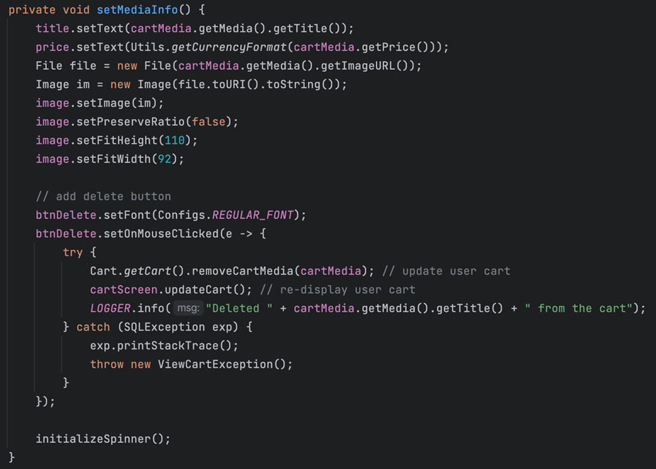

*home.MediaHandler.java*

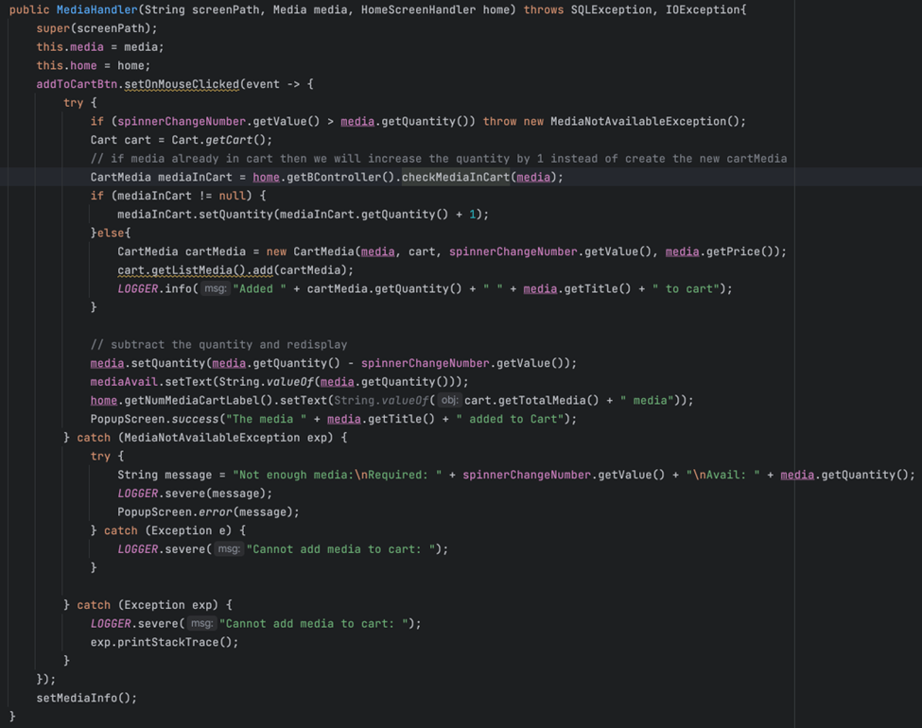

**At current design,** The handlers only focusing on handling the UI, it only communicate with controllers.

*cart.MediaHandler.java*

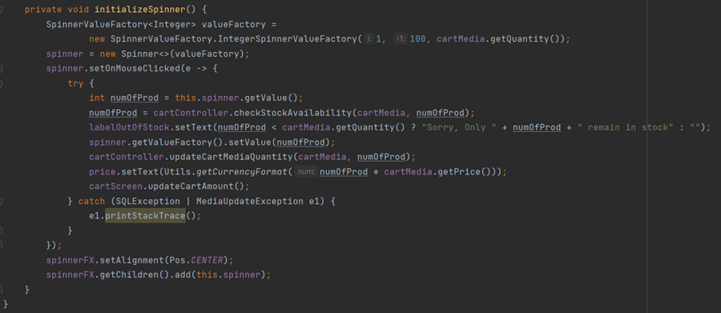

*home.MediaHandler.java*

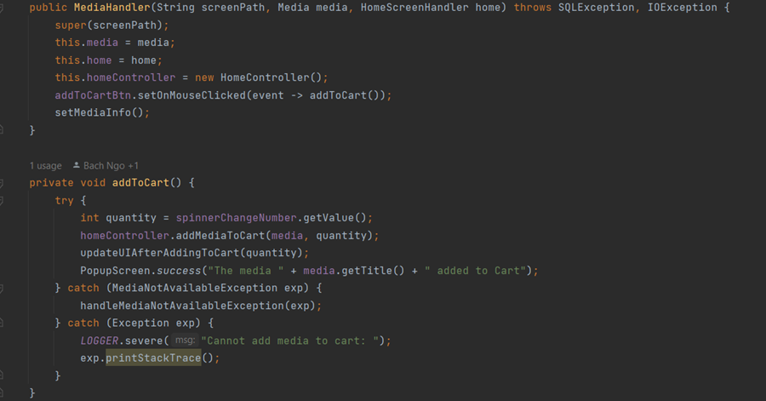**DAO**

The classes in this package are responsible for data access, indicating a high level of cohesion (functional cohesion). They exhibit stamp coupling in some methods, which is reasonable since these methods use a substantial portion of an object's data, even if not all of it.

## Design Principles

1. **Single Responsibility Principle**

Most classes adhere to the Single Responsibility Principle.

**In previous design:**

|  |  |  |
| --- | --- | --- |
| **RELATED MODULE** | **DESCRIPTION** | **IMPROVEMENT** |
| PlaceOrderController.java | The Controller performs multiple tasks simultaneously. | Create a DeliveryValidateInfo class for managing the validation of information |

*The Controller performs multiple tasks* 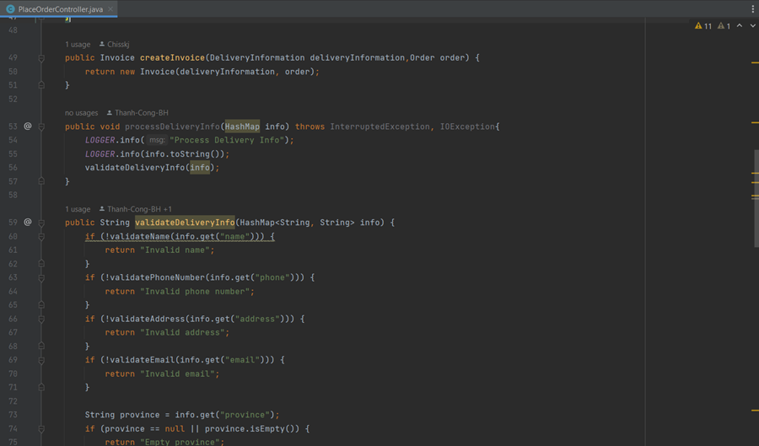

|  |  |  |
| --- | --- | --- |
| **RELATED MODULE** | **DESCRIPTION** | **IMPROVEMENT** |
| views/screen | The handler responsible for both UI management and Data access. | Separate the Handler only responsible for UI handling,  DAO for data access, and controller as the intermedia class. |

*The handler responsible for both UI management and Data access*

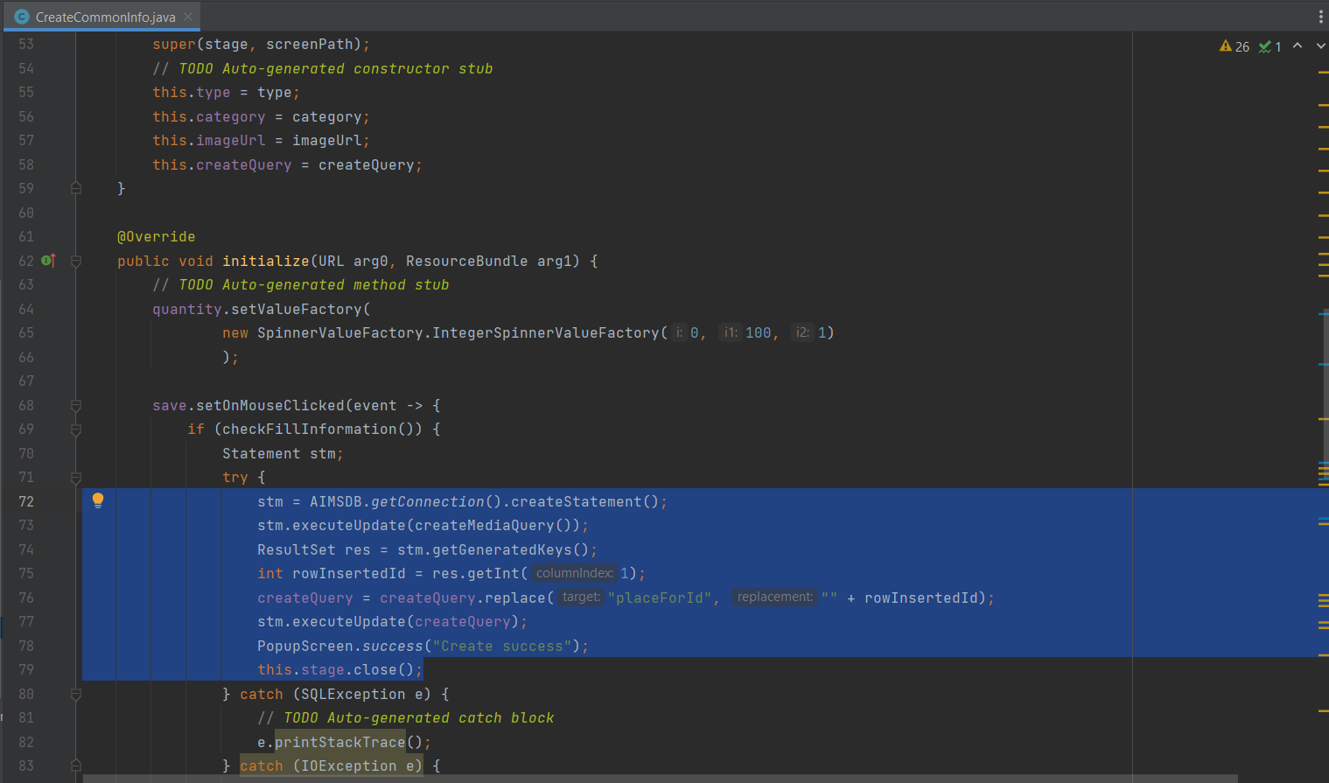

**At current design:** We have applied the improvement stated above

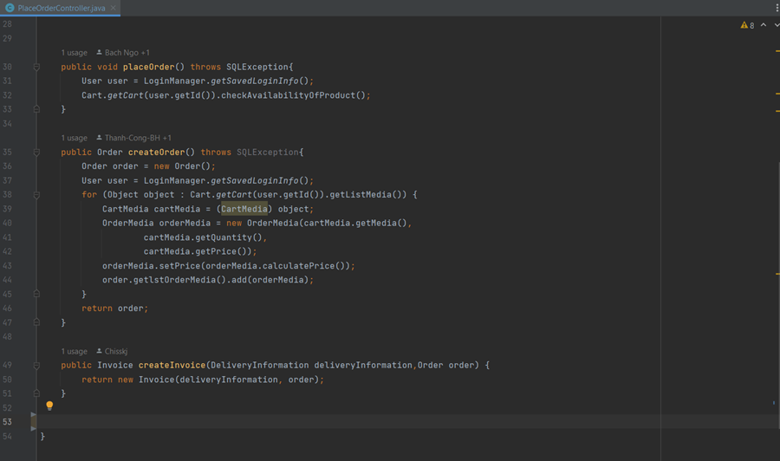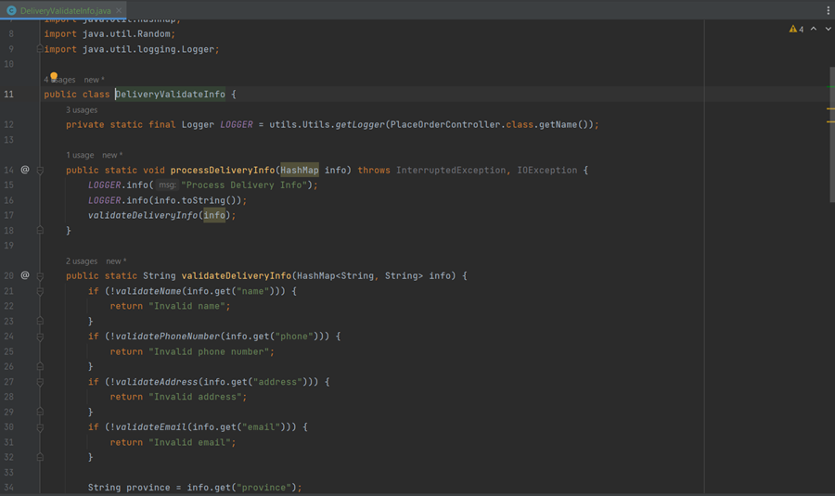*Separate the validate logic*

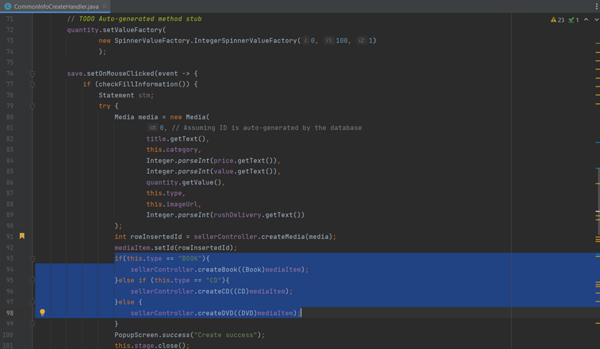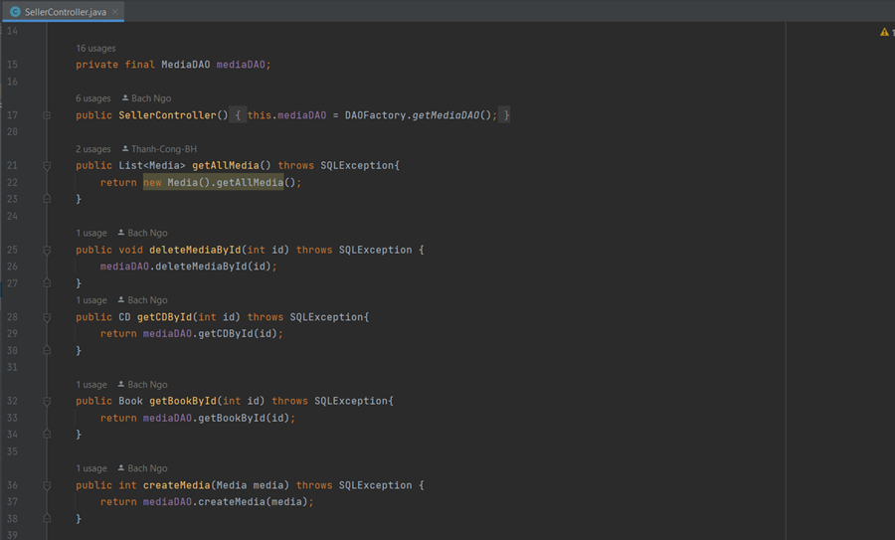*Controller as the intermediate between handler and DAO*

1. **Open/Closed Principle**

|  |  |  |
| --- | --- | --- |
| **RELATED MODULE** | **DESCRIPTION** | **IMPROVEMENT** |
| In enity/media  getAllMedia(), getMediaById(), updateMediaFieldById() | When SQLite changes the way data is organized, or when retrieving a different entity such as a book or CD, or when modifying or adding new get, update, delete functions, the code in the Media class needs to be changed. | Use DAO class responsible for accessing data |

**In previous design:**

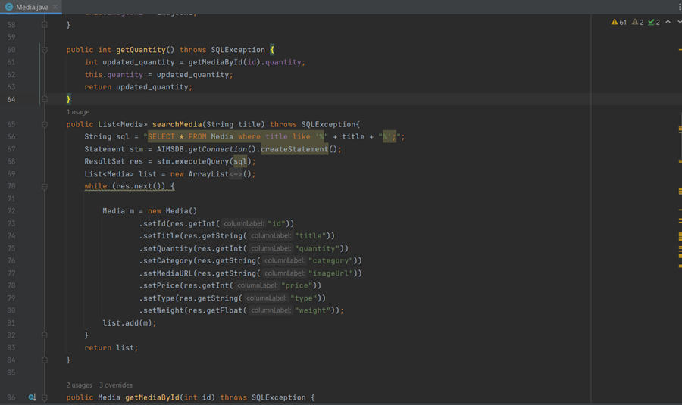  
*Accessing database directly in the entity*

**At current design:**

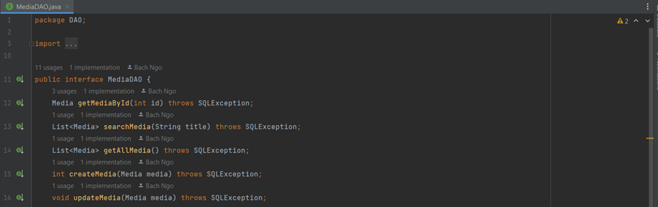*Using DAO for accessing database*

1. **Liskov substitution principle**

|  |  |  |
| --- | --- | --- |
| **RELATED MODULE** | **DESCRIPTION** | **IMPROVEMENT** |
| Media.java | The subclasses DVD, CD, and Book inherit from the Media class and override the getAllMedia() method, but they do not return the correct objects. | These methods need to be revised or removed in the subclasses. |

By using the MediaDAO represented above. We also have resolve this problem

1. **Interface segregation principle**

The ISP principle helps you design flexible and extensible software systems. By separating small and specific interfaces, you can easily add new payment methods without affecting other parts of the system.

|  |  |
| --- | --- |
| **RELATED MODULE** | **DESCRIPTION** |
| IpaymentSubsystem.java | In the future, if we expand the system to have more payment methods  then it will be easy to implement this method |

1. **Dependency inversion principle**

## Design Patterns

**DAO Pattern**: Used to separate data access logic from business logic, promoting loose coupling and single responsibility.

* Detail implementation:
  + Each object requiring database access corresponds to a DAO (Data Access Object) interface, which is then implemented by specific DAO classes.

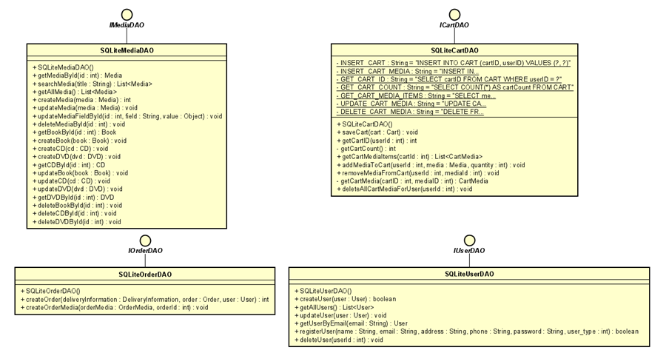

* + For instance, the SQLiteUserDAO class implements the UserDAO interface, handling user-related database operations.

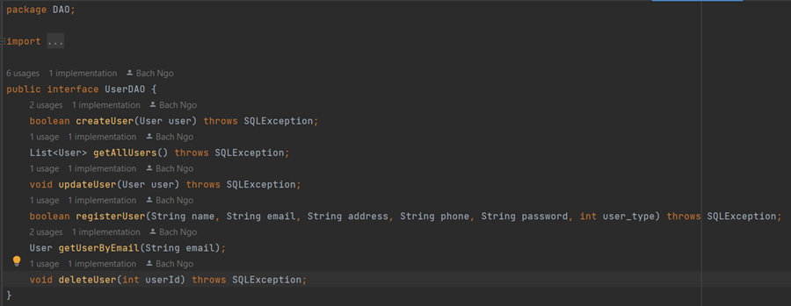

**Factory Pattern** Utilized within the DAOFactory to encapsulate the creation logic of DAO objects, facilitating flexibility in switching implementations.

* **Example Scenario**: When transitioning from SQLite to MySQL, a corresponding DAO class such as MySQLUserDAO implementing the UserDAO interface can be introduced.

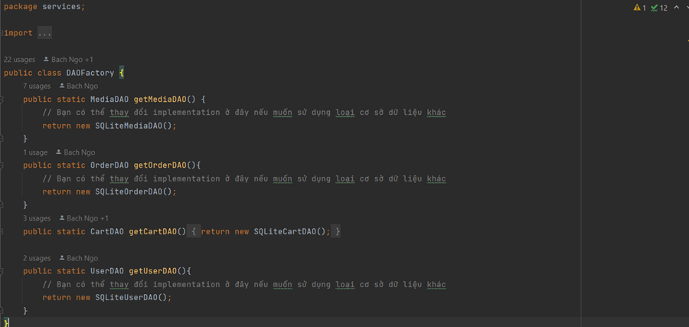

**Singleton Pattern:** Some objects that exist only once in a session of the software (AIMSDB, LOGGER) are designed according to the Singleton design pattern.

